AI, Software Development, Hardware related learning and help
Created on 28 October 2019 Last Modified on: 24 Feb 2026
----------------------------------------------------------------------------------------------------------------------
Contents
AI and LLM related learning: 2
Model Context Protocol MCP 9
Lifecycle: 9
MCP Servers: 10
MCP Clients: 11
Versioning: 12
Develop with MCP: 12
Security and Authorization: 13
AI Engineer Core Track: LLM Engineering – Udemy by Ed Donner 14
NAB AI related notes: 15
Python Learning 16
Function: 21
Python Unit Testing: 22
Exception: 23
Inbuilt functions: 23
Top Keywords in Python: 24
Codility Test: 25
Command/Help: 28
Kali LInux: 28
MariaDB and MySQL commands: 28
Linux Commands: 30
Windows Terminal Commands: 35
XML, Html, CSS: 35
Kotlin/SDK: 36
Website, Mobile App 36
GitHub: 36
Flutter: 37
App for iDOO 38
Development without coding 39
Mobile app hosting 43
Django: 43
WordPress, Website: 44
GoDaddy Hosting related information: 44
General Hosting Information 44
Android 47
Jenkins – LinkedIn Learning 52
Video Making: 53
Arduino: 53
Scratch 54
MICRO:BIT 54
Robot, Raspberry Pi: 54
WeChat Related: 56
General Note: 58

AI and LLM related learning:

25 Apr 2026:
Altaf Rehmani is host
Kimi AI agent - https://www.kimi.com/en has its own LLM
https://kling.ai/ for video generation
Claud Pro,
Nano banana
Hosting app - https://vercel.com/
https://replit.com/
https://oboe.com/
https://notebooklm.google/
https://vercel.com/
https://openclaw.ai/
Sleepdive.io – from sam, also has mobile app. To make people sleep.
Charles Lesley Manulife, compliance.
Jim, bring something valuable. Fengshui based fortune telling
VS code, Zed https://zed.dev/ - similar to Cursor IDE

10 Jan 2026:
Ollama Vs LM Studio Vs Open LLM Vs vLLM Vs Modular Max

Ollama and LM Studio are to run open source LLM locally. LM Studio provides GUI, it is not open source. However, Ollama is open source, flexible and good for developers. Summary, choose Ollam over LM Studio.

Ollama is to run on simple models on local small PC. vLLM is to manage large production grade LLM and optimize GPU. vLLM is better.

Youtube video from RedHat to host vLLM on AWS: https://www.youtube.com/watch?v=yBsHJCHx1gg
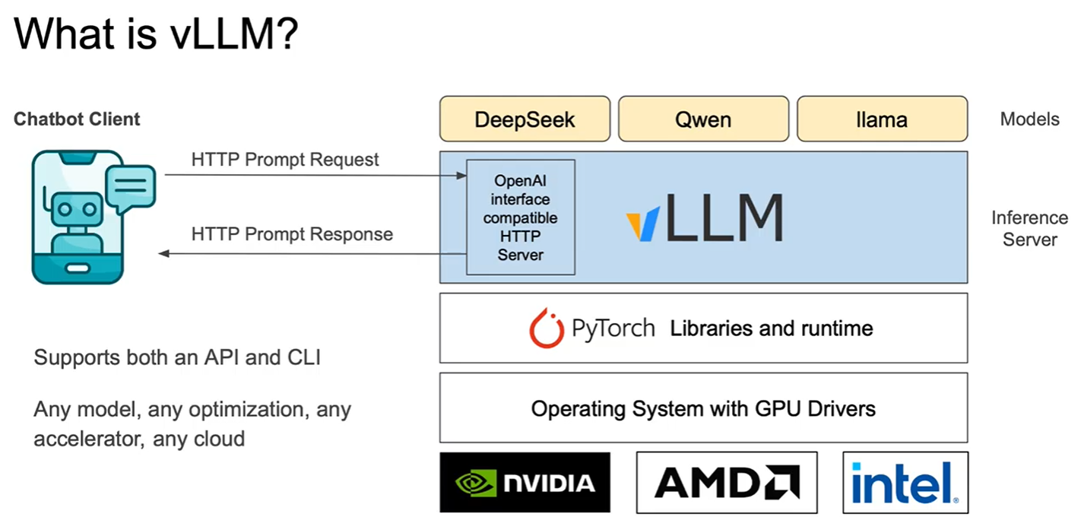

Yes, the GeForce RTX 4070 Super fully supports CUDA (Compute Unified Device Architecture) as it's an NVIDIA GPU built on the Ada Lovelace architecture, featuring numerous CUDA Cores (7168 on the 4070 Super) and compatible with the latest CUDA Toolkit for parallel computing tasks, AI, and rendering.

vLLM can’t directly run on Windows. It can run either on Docker or on Linux (using Windows Subsystem for Linux). Installing WSL on windows is more performance than through Docker, especially access to the file those are on the computer (outside of Docker). To avoid this, keep the files within the Docker/Linux environment, instead of the base windows computer. Docker installation provides easy portability and less configurations.

vLLM for windows is available as fork. However, vLLM version installed on WSL looks better.

Uv – to install & manage Python versions.
WSL to install linux on windows.

Modular Max is another product similar to vLLM. The performance reports are similar to vLLM based on reports. https://www.modular.com/ It’s a company; vLLM is by open source community.
vLLM can be installed both on Docker and Podman.

Open WebUI is the preferred UI for Ollama.
It can be integrated with Django.

- Ollama is open source command line tool to manage LLMs. LM Studio is GUI based tool to manage LLMs. Ollama is better for developers.
- Dolphine is finetuning the open source LLM remove the bias and censorship.
- Language Processing Unit LPU from groq is s chip for language processing.
- LMSYS for LLM comparison: https://lmarena.ai/leaderboard
- For vision, it requires a vision adaptor.
- HuggingChat is a open source AI chat interface for LLM. Its closed. Hugging Face is the new product with many other features ???hugg
- Cursor IDE is AI based IDE based on Visual Code.

Hosting:
Google Colab has free tier, where Ollama can be hosted and can run python code. To access it through internet, need to setup public API using ngrok or Pinggy. https://colab.research.google.com/github/5aharsh/collama/blob/main/Ollama_Setup.ipynb

Ollma and LM Studio can be hosted on local machine or on Google Colab and accessed via internet using Pinggy. https://www.youtube.com/watch?v=FQgmqxBE3f4 https://www.youtube.com/watch?v=OhWEKvYj-UE

Dynamic DNS service and Tunneling services can be used to host website on local home server and accessed through internet. Example: DuckDNS, No-IP, Tailscale, CloudFlare Tunnel.

Ngrok – ngrok is a tool that creates secure tunnels from the public internet to your local machine, allowing you to expose local web services, applications, or APIs to the outside world without complex network configurations. It works by connecting your local server to ngrok's cloud service, which then provides a public URL (like https://<random-string>.ngrok.io) that forwards traffic directly to your running application, making it accessible for testing webhooks, sharing demos, or integrating with third-party services.
Minimum US$5 setup fee and usage limit. https://ngrok.com/

Pinggy.io is a fast, secure platform for creating instant tunnels to expose local applications, services, and devices (like IoT) to the internet, enabling easy sharing, testing, and remote access without complex firewall or NAT configurations, supporting various protocols (HTTP, TCP, UDP, TLS) with features like custom domains and traffic inspection. It's used by developers to share in-progress apps, for remote debugging, and for accessing local services, often compared to tools like ngrok but offering features like direct UDP support and custom domain mapping. www.pinggy.io Free and also US$2.5per month plan.

https://f-droid.org/ - hosts android apps which are checked for their source code for privacy.

Termux is a Linux terminal emulator for Android. Run linux on android phone. https://f-droid.org/en/packages/com.termux/

------
Anyscale https://www.anyscale.com/ is a company produces Python AI framework Ray.

25 Aug 2025:
- How to run AI locally. 24 minute YouTube: https://www.youtube.com/watch?v=Wjrdr0NU4Sk&t=178s
- What is RAG (Retrieval Augmented Generation). 6 minutes IBM video: https://www.youtube.com/watch?v=T-D1OfcDW1M&t=18s
- How to build Loal AI Agents with Python. 28 min YouTube: https://www.youtube.com/watch?v=E4l91XKQSgw
- Build AI Apps locally (Ollama course): 3 hours YouTube: https://www.youtube.com/watch?v=GWB9ApTPTv4

AI related learning: https://www.kaggle.com/
LLM learning: https://github.com/hamzafarooq/building-llm-applications-from-scratch
Generative AI certificate from Nvidia: https://www.nvidia.com/en-us/learn/certification/generative-ai-llm-associate/
Tamil Llamma: https://github.com/abhinand5/tamil-llama
OWASP top 10 for LLM and Gen AI: https://genai.owasp.org/llm-top-10/
Understand LLM model and create applications using LLM in Tamil or use in Cyber Security.

Software Development tools:
IDE: Antigravity from Google, its free.
IDE: Cursor – cursor has free version. Windsurf – also has free version
WisprFlow – audio to text converter. Have free version.
AI assistant https://abacus.ai/
Lovable is to generate front end. https://lovable.dev/
LiveKit Develop real time audio, video apps: https://docs.livekit.io/home/
ChromaDB – vector database. Can host locally as open source
MangoDB – no SQL DB, can be used as vector DB.
LlamaIndex to connect with external documents.

Action: Develop a AI web application using Django.

https://www.youtube.com/watch?v=E4l91XKQSgw&t=34s
https://www.youtube.com/watch?v=sVcwVQRHIc8&t=1s
https://www.youtube.com/watch?v=AUQJ9eeP-Ls
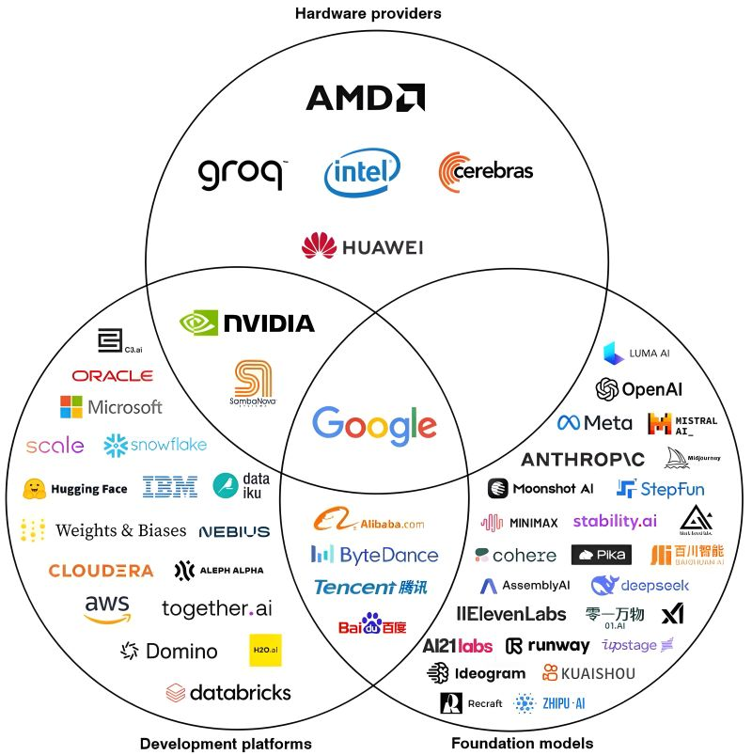

Open-source LLMs: Uncensored & secure AI locally with RAG – Udemy, by Arnold Oberleiter
28 Sep 2025:
- LLM has two files: Parameter file, Run file. Parameter file is the compressed version of the data. Run file is about 500 lines of code written in C or Python. Creating Parameter file requires GPU.
- Each LLM has token limit. Token is the number conversion of part of a text. Typically 4 character is a token. LLM can’t understand beyond its token limit. It can only know the latest past tokens.
- Automation tools: n8n, Make, Zapier, LangChain, Flowise,???
- Pretraining Finetuning Reinforcement.
- Test Time Computer TTC – amount of time the model takes to give response. Thinking model is expensive.
- Function Calling – calling another LLM or systems to get an output for the LLM.
- Retrieval-augmented generation is a technique for enhancing the accuracy and reliability of generative AI models with information from specific and relevant data sources.
- Nvidia blueprints: https://build.nvidia.com/blueprints
- Retrieval Augmented Generation RAG
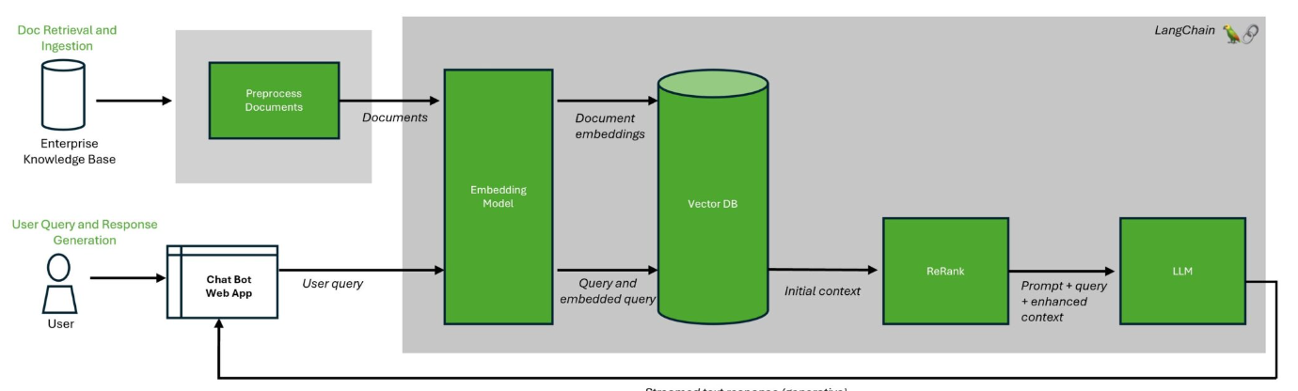
- Function calling allows LLM to interact with external tools and APIs. RAG enables LLM to access & use information from external knowledge sources.

N8N:
- N8n runs on Node JS or on Docker. First install Node JS. NVM for windows can help install and switch between multiple versions of Node JS on the same machine.
  - Install nvm-setup.zip file from this location: https://github.com/coreybutler/nvm-windows/releases
- N8n on docker is better for production deployment. N8n on Node JS is better for development.
- Download n8n at: https://github.com/n8n-io/n8n
- Download Node JS at: https://nodejs.org/en
- After Node JS is installed, type this command in cmd to install n8n: npm install n8n -g. npm is the command to install package in Node JS. NPM – Node Package Manager.
  - To start n8n run: n8n on cmd prompt
  - Login: iit.amirtharaj@gmail.com/AI@123456
  - http://localhost:5678/home/workflows
  - To update n8n, run the command on cmd prompt: npm update -g n8n

- To know the VRAM size, type dxdiag on windows Run.
- List of LLM installed on local machine, run on cmd prompt: ollama list, ollama rm <model name> - remove LLM.
- Milvus is a better open source vector database.

AI RAG LangChain youtube video
08 Dec 2025:
Indexing:
- Converting text into searchable format. Using statistical frequency of the words. Sparse. BM25
- Other way used in machine learning is to convert the text into vector Vector is indexed. Embedding, Dense, KNN, NNSW
Query Translation:
- IR-CoT: Interleave retrieval with CoT
- HyDE – approach to transform question. HyDE circumvents the aforementioned learning problem by performing search in document only embedding space that captures document-document similarity.
  - Take question and map into a hypothetical document.
Routing:
- Route the query to the right data source.
- Logical routing, based on LLM’s knowledge
- Semantic routing –

Query Construction:
- Natural language to a structure quary of metadata. Use function calling.
- Take metadata into the query into the fuction to LLM
- Filter metadata while processing the question

Multi-representation Indexing
- Proposition Indexing. Taking the document feeding to LLM to get the summary for indexing.
RAPTOR Indexing
- Hierarchical indexing

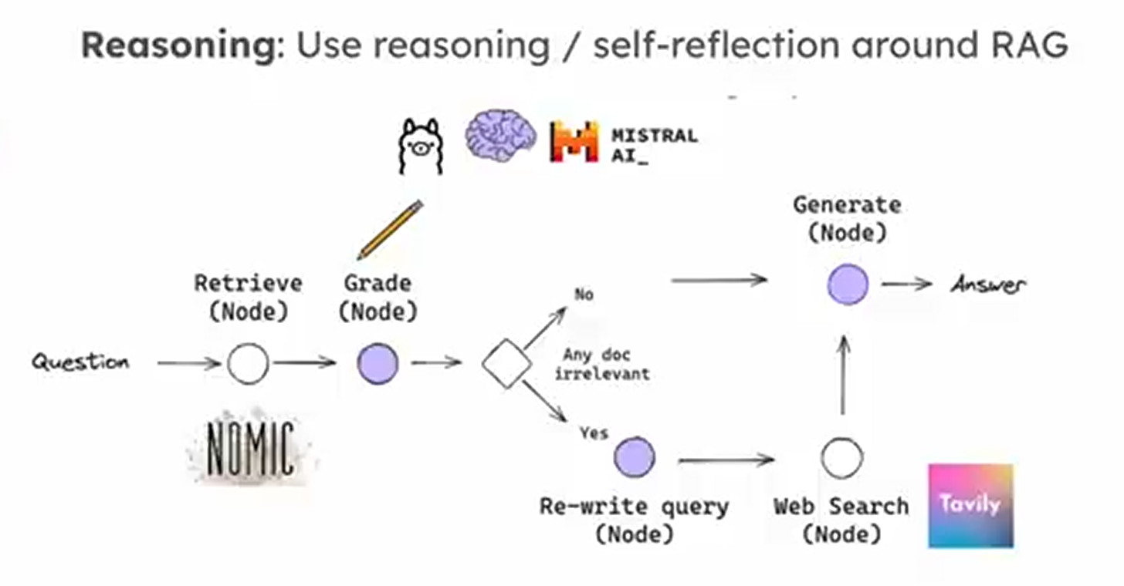
Python RAG AI application YouTube video:
08 Dec 2025 – video sponsored by Inngest.
It uses Inngest for orgestration and gui
Streamlit for frontedn
Qdrant for vector database.
LlamaIndex for pdf ingesting
OpenAI for AI

Model Context Protocol MCP:
It is an open-source standard for connecting AI applications to external systems.
While RAG and MCP are to provide additional external information to improve accuracy and reduce hallucinations, RAG is read only information, MCP is action oriented – read and act.

MCP follows a client-server architecture where an MCP host — an AI application like Claude Code or Claude Desktop — establishes connections to one or more MCP servers. The MCP host accomplishes this by creating one MCP client for each MCP server. Each MCP client maintains a dedicated connection with its corresponding MCP server.

STDIO runs locally.
Sentry MCP server runs remote. Uses streamable HTTP transport.

MCP has two layers:
Data Layer, Data Layer users JSON-RPC

Transport Layer. Transport layer manages connection, security, message framing. Two transport mechanisms: STDIO, standard input out communication between client and server. Stay within the same machine, no network involved.
Streamable HTTP transport uses HTTP POST, with optional Server-Sent Events. Supports standard HTTP authentication – bearer token, API keys, custom headers, OAuth

MCP is a stateful protocol which requires life cycle management.

Primitives: defines what client and server can communicate. Primitive specify the type of context can be shared between client and server, and the range of actions can be performed.

3 primitive server can expose:
Tools: executable functions AI applications can invoke to perform actions. Eg: query database
Resources: data resources that can provide context to AI applications.
Prompts: reusable templates to interact with language models.
Each primitive type has a method to discover available primitives. Eg: tools/list, */get.

Primitives that client can expose:
Sampling: Allows servers to request language model completions from the client’s AI application.
Elicitation: Allows servers to request additional information from users.
Logging: Enables servers to send log messages to clients for debugging and monitoring purposes

Cross cutting utility primitive: Tasks.
Notifications are sent as JSON, without expecting response.

Lifecycle:
Step 1: Initialize: method: initialize
Protocol version is mandatory, drop the connection if it is not matching.
Capability Discovery
Client Info, Server Info
After exchanging initialization, client sends notification to indicate that its ready. Method: notifications/initialized.

During initialization, the AI application’s MCP client manager establishes connections to configured servers and stores their capabilities for later use. The application uses this information to determine which servers can provide specific types of functionalities (tools, resources, prompts) and whether they support real-time updates.

Step 2: client can discover available tools by sending a tools/list request. Understand the available tools, before attempting to use it.
Method: tools/list
Tools list response include details such as: name, title, description, inputSchema.

The AI application fetches available tools from all connected MCP servers and combines them into a unified tool registry that the language model can access. This allows the LLM to understand what actions it can perform and automatically generates the appropriate tool calls during conversations.

Step 3: Tool execution.
Client can execute tools using tools/call method. Key elements are tool execution are:
Name – must match with the name in discovery response.
Arguments – input parameters, matches with the inputSchema
JSON-RPC structure with unique id to identify the request-response correlation.
Response has – content, type, structured output

Step 4: Real-time updates
RCP supports real time updates from Server to inform any changes without being explicitly requested. "method": "notifications/tools/list_changed"
No response required,
It is capability based. "listChanged": true in initiation.
Even driven.

Step 5: Shutdown
During the shutdown phase, one side (usually the client) cleanly terminates the protocol connection. No specific shutdown messages are defined—instead, the underlying transport mechanism should be used to signal connection termination

MCP Servers:
Each resource has a unique URI (e.g., file:///path/to/document.md) and declares its MIME type for appropriate content handling.
- Direct Resources - fixed URIs that point to specific data. Example: calendar://events/2024 - returns calendar availability for 2024
- Resource Templates - dynamic URIs with parameters for flexible queries. Example:
  - travel://activities/{city}/{category} - returns activities by city and category
  - travel://activities/barcelona/museums - returns all museums in Barcelona

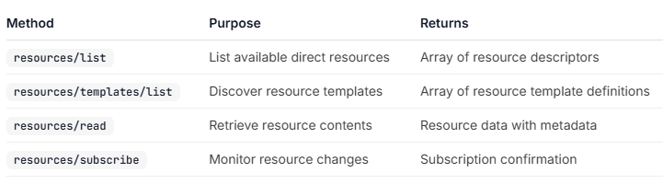
A MIME type (Multipurpose Internet Mail Extensions), now officially called a Media Type, is a standardized label used to identify the format and nature of a file or data stream transmitted over the internet.

Prompts are structured templates that define expected inputs and interaction patterns. Rather than unstructured natural language input, the prompt system enables consistent workflow execution based on the template
Prompt/list – discover the list of available prompts.
Prompt/get – get full prompt definition with arguments

Multiple servers work together.

MCP Clients:
The host is the application users interact with, while clients are the protocol-level components that enable server connections.

Elicitation interactions are designed to be clear, contextual, and respectful of user autonomy:
Request presentation: Clients display elicitation requests with clear context about which server is asking, why the information is needed, and how it will be used.
Response options: Users can provide the requested information through appropriate UI controls (text fields, dropdowns, checkboxes), decline to provide information with optional explanation, or cancel the entire operation.
Privacy considerations: Elicitation never requests passwords or API keys. Clients warn about suspicious requests and let users review data before sending.

Roots define filesystem boundaries for server operations, allowing clients to specify which directories servers should focus on.
While roots communicate intended boundaries, they do not enforce security restrictions. Actual security must be enforced at the operating system level, via file permissions and/or sandboxing. Roots are exclusively filesystem paths and always use the file:// URI scheme.
The roots list can be updated dynamically as users work with different projects or folders, with servers receiving notifications through roots/list_changed when boundaries change.
The client updates the roots list via roots/list_changed.

Roots serve as a coordination mechanism between clients and servers, not a security boundary. The specification requires that servers “SHOULD respect root boundaries,” and not that they “MUST enforce” them, because servers run code the client cannot control. Roots work best when servers are trusted or vetted, users understand their advisory nature, and the goal is preventing accidents rather than stopping malicious behavior.

Sampling enables servers to perform AI-dependent tasks without directly integrating with or paying for AI models. Instead, servers can request that the client—which already has AI model access—handle these tasks on their behalf. The flow ensures security through multiple human-in-the-loop checkpoints. Users review and can modify both the initial request and the generated response before it returns to the server.

While not a requirement, sampling is designed to allow human-in-the-loop control. Users can maintain oversight through several mechanisms: Approval controls, Transparency features, Configuration options, Security considerations: Clients should implement rate limiting and validate all message content. The human-in-the-loop design ensures that server-initiated AI interactions cannot compromise security or access sensitive data without explicit user consent.

Versioning:
The Model Context Protocol uses string-based version identifiers following the format YYYY-MM-DD, to indicate the last date backwards incompatible changes were made.

Draft: in-progress specifications, not yet ready for consumption.
Current: the current protocol version, which is ready for use and may continue to receive backwards compatible changes.
Final: past, complete specifications that will not be changed.

Version negotiation happens during initialization. Clients and servers MAY support multiple protocol versions simultaneously, but they MUST agree on a single version to use for the session.

Develop with MCP:
Connect with local MCP Server:
Model Context Protocol (MCP) servers extend AI applications’ capabilities by providing secure, controlled access to local resources and tools. The Filesystem Server and many other MCP servers require Node.js to run. All actions require your explicit approval before execution, ensuring you maintain full control over what Claude can access and modify.

Connect with remote MCP servers:
Security considerations: always verify the authenticity of remote MCP server before connecting. Cautious about granting access to sensitive data or systems.
Can connect to multiple remote MCP servers simultaneously. Organize connections based on purpose or project. Periodically remove the connections no longer required.

For STDIO-based servers: Never write to stdout. Writing to stdout will corrupt the JSON-RPC messages and break your server. The print() function writes to stdout by default, but can be used safely with file=sys.stderr.
For HTTP-based servers: Standard output logging is fine since it doesn’t interfere with HTTP responses. Use a logging library that writes to stderr or files.

Fastmcp. Gofastmcp.com is an open source to build MCP server using Python.

Security and Authorization:
Use OAuth authorization when:
- grants access to user data, PII, sensitive data
- need to audit who performed which actions
- APIs that require user consent
- need to implement rate limiting or usage tracking per user.

For Local MCP servers, because it is using STOIO transport, it may not rely on browser authentication and authorization. So, OAuth may not be applicable.

Remote MCP Server Authorization Flow:
OAuth is used for HTTP based remote MCP servers.
- Initial Handshake: when MCP client first tries to connect, server responds with 401 Unauthorized and tells client where to find authorization information (PRM document) and is provided in resource_metadata parameter within WWW-Authenticate header.
- The client point to PRM to fetch the metadata to learn about authorization server, scopes, resources. Typically it is an JSON blob. (A JSON blob is a common, informal term used by developers to describe a large, unstructured, or opaque collection of JSON data. It is often used to refer to data that is stored or transmitted as a single, "solid" unit rather than being broken down into individual database fields or objects.)
- Client to register with authorization server. It can be done in two ways: pre-registered, or Dynamic Client Registration (DCR) if supported. If registration is successful, authorization server returns a JSON blob with client registration information.
- Client open browser to /authorize end point where user login. The authorization server will redirect back to client with authorization code. It follows standard OAuth 2.1 with PKCE.
- Client will use access to authenticate requests to MCP server.

Common best practices:
- Use well-tested secure libraries for token validation and authorization
- Use short-lived access tokens
- Always validate token
- Store tokens in encrypted storage
- Enforce https, do not accept http
- Do not log credentials. Never log authorization headers, tokens, secrets
- Separate app server and resource server credentials
- Unauthenticated DCR means anyone can register any client with server. Avoid it
- Return generic error message, without exposing internals
- Avoid using static client ID for MCP proxy server for third-party authorization server. Must implement per-client consent, before third-party authorization flow.
- To avoid server-side request forgery SSRF (HTTP making request to unintended destination), block private IP range, MCP clients must require HTTPS for all OAuth URLs (HTTP not allowed)
- Additional guardrails and explicit user consent for commands that will be executed, especially for potentially dangerous commands like sudo, rm -rf
- Run MCP server with least privilege, and run commands in sandboxed environment
- Avoid publishing all possible scope in scope_supported, avoid using wildcard scope

OWASP MCP Top 10: https://owasp.org/www-project-mcp-top-10/

Azure AD can support MCP server OAuth authentication. However, it does not support DCR. So require manual pre-registration.
Keycloak is an open source authorization server hosted in a Docker container.

AI Software:

Anthropic Mythos (or Claude Mythos) is an advanced, unreleased frontier AI model developed by Anthropic to autonomously find and exploit complex software vulnerabilities, marking a significant step in AI cybersecurity. Announced in April 2026, it is restricted to partners under Project Glasswing for defensive security work due to its potential to find decades-old, high-severity bugs without human intervention. https://www.anthropic.com/glasswing

AI Engineer Core Track: LLM Engineering – Udemy by Ed Donner
12 Oct 2025:

AI Engineer Core Track: LLM, RAG, Agents
23 Nov 2025:
Cursor.ai command: Ctrl+Shift+P to get to the command prompt. Then type the search.
To check Python uv version: uv --version. If error, means uv is not installed.
After installation do update: uv self update
To set up the environment: uv sync

23 Jan 2026:
.py – python file
.ipynb – python note book file

Cursor:
- .mdc file in cursor is to provide rules to cursor agent
- .nenv – stores the local python virtual environment dependencies.
- .env – to store API keys. OPENAI_API_KEY= <write the api key from Open AI>. .env file is not viewed by Cursor.
- @ - to provide reference to cursor. Example @utils.ts file, @folder name, @git recent changes, @web latest in next.js
- CONTEXT.md – file to write the context information and reference it using @
- .cursor/rules – rules. .cursor/rules/general.mdc, react.mdc etc

- Cursor IDE has terminal at the bottom.
- View extensions – to install extensions such as Python
- Click on “select kernel”/the python version already chosen – to select different python environment.

- Ollama local host: http://localhost:11434/
- Open WebUI to add gui to Ollama. https://github.com/open-webui/open-webui
- Unslothai to train Ollama model: https://github.com/unslothai/unsloth
- Can run two ollama in one windows machine. Simply run two different models from CLI.
- To access them through different URL, change the second model’s port using OLLAMA_HOST variable name.
- Ollama binds 127.0.0.1 port 11434 by default. Change the bind address with the OLLAMA_HOST environment variable.

NAB AI related notes:
28 Sep 2025: AI for cyber security proposal.
Garak from Nvidia is open source for LLM vulnerability scan.

Business Objective:
Reduce FTE by 70% using AI.

3 Use Cases for the 1st year:
- Business & project teams Self-service for Security Architect (and/or Group Security) engagements/approvals
- Due diligence activities simplification for Security control assessment of Epic/project/SRR (formerly PRR)
- Fundamentally changing Software as a Service (SaaS) security control assessment

How:
Generally, implementation and the technologies used are not the concern during initial Project Charter (business case) phase. However, in this case, those are important to be discussed early at stage:
- Use existing AI like ChatGPT, Gemini, CoPilot etc Vs Build own AI using open source LLM.
  - Recommendation is to build own AI opensource LLM (LangChain, CrewAI, AutoGen)
- Buy AI services integrating wit Use Case Vs Build internally with whatever we have.
  - Recommendation is the combination of both. Example purchase: n8n, SAFE

Resource Requirements:
- Doers 80%, Enablers 20%. 80% people with skills to “do” the actual tasks.
- Interest and Willingness are more important than technical skills requirements.
- Development and Testing environment.

Major timeline/phases:
- Project Charter and Business Case preparation & confirmation – now till 31 Oct 2025
- Development & Testing environment preparation – now till 06 Nov 2025
- Resource identification and allocation – now till 28 Nov 2025
- Project kick off – 10 Nov 2025
- Base framework ready – 23 Jan 2026
- First use case pilot – 10 Nov 2025 – 27 Mar 2026
- Project progress executive review – 17 Apr 2026
- Management review & confirmation for first pilot use case – 17 Apr 2026
- Second use case pilot – 10 Apr 2026 – 29 May 2026
- First use case rollout preparation – 10 Arp 2025 – 24 Apr 2026
- First use case rollout – 27 Apr 2026
- Management review & confirmation for second pilot use case – 12 June 2026
- Third use case pilot – 05 June 2026– 26 June 2025
- Second use case rollout preparation –
- Second use case rollout –
- Management review & confirmation for third pilot use case –
- Third use case rollout preparation –
- Third use case rollout –
- Business outcome estimation – 27 Apr 2026 – 24 July 2026
- Project progress executive review – 24 July 2026
- Project closure – 30 July 2026

Key Success Factors:
- Availability of Development & Testing environment before project kick off – 10 Nov 2025
- Resource allocation as early as possible – before 28 Nov 2025
- Executive support and understanding that there could be challenges for the first 6 months, because we are trying something new.

How to measure Objective and business outcome
- TBD

Python Learning
Python basics you tube learning: https://www.youtube.com/watch?v=ygXn5nV5qFc https://python.datalumina.com/practical-python/organizing-code

Python Tutorial: https://www.w3schools.com/python/
26 Nov 2025:
Formatted string f-string is used to display variables or python expressions within String. Variable or python code are within curly brances {}
number = [1, 2, 4, 6]
print(f"Number: {number}")
return f”number:{umber}”

f – is used to embed variables and expressions into string. Can use expression, if condition, calling function are allowed
print(f”true or false” {True if a==0 else False})
print(f”write the name” {person.name()})

print(‘test text’, end=’’) – end= is to continue printing on the same line.

# - comments for a line
“”” text “”” – multiple line text between 6 quotes
Semicolon ; is use to separate statements if they are written in the same line. Generally no one uses semicolon in python.

If temperature > 25:
Action
else:
action

for i in range(5):
action
The for loop value i starts from 0 till 4.

for i in n (n for n in number if n ==10):

range(start, stop, step), range(stop), range(start, stop)
Default start is 0, end is the provided number, step is 1.

while count <5:
action

while count <5:
action
else:
execute actions when the while condition is false
Infinite loop.
While True:
Action

Use break key word to exit the while loop.

use end parameter within print to print multiple words on same line.
print("Hello World!", end=" ")
print("I will print on the same line.")

print can print number, string, arithmetic expression, combination of number and text.

Variables are automatically assigned based on the value, no command for declaring. Variable can also change type.
Variable type can be declared using casting:
x = str(3) # x will be '3'
y = int(3) # y will be 3
z = float(3) # z will be 3.0

type() – to get variable type

Both single quote and double quote for string are the same in Python. General convention is: use single quote when double quote is inside; use double quote when single quote is inside and when it has message for end users.

Variable names are case sensitive.
Variable created outside of function is Global variable.
Text Type: | str
Numeric Types: | int, float, complex
Sequence Types: | List [], tuple (), range – range function generates a sequence of numbers range(start, stop, step)
Mapping Type: | Dict – store date in key value pair {key: value, key: value}
Set Types: | set, frozenset
Boolean Type: | bool
Binary Types: | bytes, bytearray, memoryview
None Type: | NoneType

Assign multiline string to a variable by using three quotes or three single quotes. A = “””this is the multline texsdffjskfhskdhfkjsd”””

Len() – length of a string
Upper(), lower(), strip() – remove any whitespace from beginning or end
Replace() – replace string
Split() – splits string

\ as escape to use illegal character. Character after \ is ignored.

Any string is True.
Any number is True except 0

// - floor division – rounds the results to integer of quotient.
% - modulus, reminder
** - exponent
:= - Walrus operator to assign value to a variable as part of larger expression and also return the assigned value.

In, not in – membership operators

& - bitwise AND
| - bitwise OR
^ - bitwise XOR
- - bitwise NOT
<< - shift left with right most bit as zero
>> - shift right

Mylist = [“fsfds”, “dfd”]
First list index is 0
List can be empty. Mylist=[]

xrange command is python 2 command. Python 3 range commands works same as xrange

Append() – add list item to the end
Insert() – inserts a specific item at the specified index.
Extend() – add one list with another list or tuples or sets or dict
Remove() – removes specific item
Pop() – removes the item specificed by index pop(2). If no index specified, then removes the last one.
My_list.pop() will return the last removed list, and the my_list is updated with last removed.
Sort() – sort alphanumerically, ascending by default. Sort method is case sensitive, Capital letter first and then lower case letters. Sort(reverse = True) – to make sorting descending. Sort(key = function) – to use the function for sorting.
Reverse() – reverse the order, irrespective of the alphabet
Copy() – copy the list
Del – delete the specific index item or deletes completely

09 Dec 2025:
Lopp list:
Mylist = [“fsdfsd”, “dfdsfds”]
For x in mylist:
Print (x)

[:] – slice operator, allows extracting the portion of a list or string, or tuple. [start:stop:step]
Default is the 0 start and last is the end
[::2] – every second element – 0, 2, 4 th elements.
[1:3] – element at index 1, 2 (please note, not the 3d index and not the 0 index)
[::-1] – reverse = -1, -2, -3 etc…

At Python Tuples

Udemy Learning – The Complete Python Bootcamp
10 Dec 2025:
Dictionaries: {‘key1’:’value1’,’key2:value2}
Data can not be ordered in dictionaries. Value within an Dictionary can be a List or another Dictionary.
List: [] or list() key word
Tuples: (1,2,3) Or use tuple() key word. Tuple can be written within paranthesis () or whithout it. Similar to List, but are immutable, the value can’t be reassigned. Tuples are memory efficient than List. Tuples are used to store data which shouldn’t be changed.
Sets: {1,2,3} or set() key word. Must be unique values.
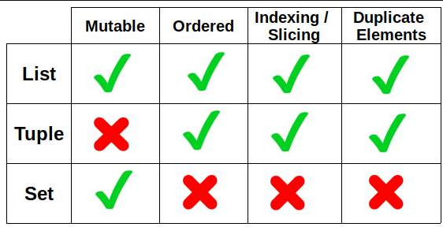
Order of data printed from set({} or []) and Dictionary {} are arbitrary. Order in a List [] is same as the stored order.

List [], Dictonary {}, Set {}, Tuple ()

My_set = set(my_list) – to convert list into set
My_sort_set = sorted(my_set) – to sort a set

I/O files:
Myfile.read() – to read file as a string. The cursor is set at the end of the string. To read the file again, need to set the cursor to 0. Myfile.seek(0).
Myfile.readline() – read file as each line.
Myfileclose() – to close the file.
To access a file at different location than Pything, then provide the full file path. For windows, provide two back slash \\ for each of the folder structure.
Use “with” key word before open() to open file.
With open(‘myfile.txt’) as mynewfile:
Content = mynewfile.read()
File modes:
Mode=’r’ – read only
Mode=’w’ – write only
Mode=’a’ – append only
Mode=’r+’ – reading and writing
Mode=’w+’ – writing and reading

If Controls:
Control flow is based on : colon or indentation whitespace.
If condition:
Control flow
Else:
Control flow

Elif – to add additional condition after if. Can have multiple elif.
If condition:
Control flow
Elif condition:
Control clow
Else:
Control flow

if condition1:
# Code to execute if condition1 is True
elif condition2:
# Code to execute if condition1 is False and condition2 is True
elif condition3:
# Code to execute if condition1 and condition2 are False and condition3 is True
else:
# Code to execute if all preceding conditions are False

Function:
def is the key word for function declaration
def myfunction():
the function code here

def myfunction(parameter):
print(f”here is the {parameter}”)
myfunction(“how are you”)

def myfunction(parameter):
new_parameter=”Hello”+parameter
return new_parameter

default arguments can be provided in function declaration to use if one of the parameter is missing.

Python allows functions to accept an arbitrary number of arguments using *args for non-keyword arguments and **kwargs for keyword arguments.

def add_all(*numbers):
return sum(numbers)
print(add_all(1, 2, 3, 4))

def greet(**kwargs):
for key, value in kwargs.items():
print(f"{key}: {value}")
greet(name="John", greeting="Hello")

A recursive function is a function that calls itself. This is useful for tasks that can be broken down into smaller, similar tasks.
def factorial(n):
if n == 0:
return 1
else:
return n * factorial(n - 1)
print(factorial(5))

A lambda function in Python is a small, anonymous function defined using the lambda keyword. Unlike regular functions defined with the def keyword, lambda functions are typically used for short, immediate operations and can only contain a single expression.
lambda arguments: expression.

# A lambda function that multiplies two arguments
multiply = lambda a, b: a * b
print(multiply(5, 6)) # Output: 30

Lambda functions are particularly useful when used as anonymous functions inside other functions or with higher-order functions like map(), filter(), and reduce().

Python Unit Testing:
import unittest

class SomeClass(unittest.TestCase):
def testcase1(self):
self.assertEqual(testingfunction(inputdata), result)

def testcase2(self):
self.assertTrue(testfunction(inputdata), result)

def testcaes3(self):
self.assertFalse(testfunction(inputdata), result)

def testcaes4(self):
self.assertRaises(testfunction(inputdata), result)

if __name__==”__main__”:
unittest.main()

The if __name__ =="__main__" idiom in Python is used to execute code only when the file is run as a script, not when it is imported as a module. When a Python file is run, the interpreter sets a few special variables before executing the code. One of these variables is __name__. If the file is being run as the main program, __name__ is set to "__main__". If the file is being imported from another module, __name__ is set to the module's name.

assertEqual, assertNotEqual, assertTrue, assertFalse, assertRaises,

Exception:
Exception class is Python exception. It is derived from BaseException class.
ValueError – Raised when an operation or function receives an argument that has the right type but an inappropriate value, and the situation is not described by a more precise exception such as IndexError.
TypeError - Raised when an operation or function is applied to an object of inappropriate type.

The try block lets you test a block of code for errors.
The except block lets you handle the error.
The else block lets you execute code when there is no error.
The finally block lets you execute code, regardless of the result of the try- and except blocks.

try:
try block
except:
error block
else:
code to execute when no error
finally:
code executed irrespective of error or not

if not len(A): - execute code if the List is empty.

Rand_number = random.randint(min, max) – generate random number between min and max. Includes min and max.
Random.randrange(min,max) – excludes min and max. randrange is high performance than randint.

Divmod(dividend,divisor) – returns quotient and reminder

Range(start, stop, step) – range function for iteration. Starts from 0, default increment is 1.
Len(A) – length of the item A
Enumerate(array) – to get the index and value. For i, item in enumerate(array):

Inbuilt functions:
Calss MyClass:
Def __init__(self, attribute1, attribute2):
Self.attribute1 = attribute
Self.attribute2 = attribute2

__init__() function is initialized when an object is created from the class.

“self” is used to modify the specific instance. “self” is not a key word, and used as the first parameter as general conventions.

Import:
To import a complete package: import math
To import part of the package: from math import pi
To import package and create an alias name for the package: import math as m

- Zip() – function to combine multiple elements into one iterator of tuple. Zip(A,B)
- Def solution(A:list, B:list) – means the function expects both A and B as list.
- Def solution(A,B) --> list – list here means that the return value is list. Its easy for reading and for static code testing tool can validate the code before return. Its optional. Even if your declare as list, the return value can be something else and the code will not produce any error.
- A.index(5) – returns the index of the value 5 in list A
- A.count(5) – returns the count of value 5 in list A
- Abs() – return the absolute value. The positive integer value from zero.
- Abs() can’t directly work on the list. Each element needs to be converted into absolute value. Or use numpy package function abs(). Or use map() function to apply abs function to every item.
- string.replace(“x”,”y”) – replace x by y in the string
- string.lower() – change the string to lower case.

Top Keywords in Python:
1. Control Flow & Decision Making
These manage the logic and direction of your program.
- if, elif, else: Used for conditional branching based on truth values.
- for, while: Used to create loops for iterating over sequences or repeating tasks while a condition is met.
- break, continue: Used inside loops to exit early or skip to the next iteration, respectively.
- pass: A null statement acting as a placeholder where code is syntactically required but no action is needed.
2. Structural & Definition Keywords
Used to define the building blocks of a program.
- def: Used to define a new function.
- class: Used to define a new class for object-oriented programming.
- return: Exits a function and optionally sends a value back to the caller.
- lambda: Creates small, anonymous "one-line" functions.
- yield: Used in generator functions to produce a series of values lazily.
3. Logical, Membership & Identity Operators
These keywords are used for comparisons and Boolean logic.
- and, or, not: Perform logical operations.
- in: Checks if a value exists within a sequence like a list or string.
- is: Tests for object identity (whether two references point to the exact same object in memory).
4. Exception Handling
Used to manage errors and ensure program stability.
- try, except: Used to catch and handle errors that occur during execution.
- finally: Defines a block of code that runs regardless of whether an error occurred.
- raise: Manually triggers an exception.
5. Importing & Modules
Used to bring in external code or libraries.
- import, from: Include entire modules or specific parts of them.
- as: Creates an alias for an imported module to make it easier to reference (e.g., import pandas as pd).
6. Constant Values
These represent fundamental singleton objects.
- True, False: Boolean truth values.
- None: Represents the absence of a value or a null value

Codility Test:
Other screening tools are: CoderPad, HackerRank. CoderPad has free python online IDE.

Easy exercises:
- BinaryGap
  - Convert to binary using bin(). Remove the first two digit0b using [2:]. Set counter to count if 0, when reaches 1, find max and reset counter.
- CyclicRotation,
  - Before mod operation check whether the list is empty. If empty return list.
  - Find mod of rotation to the length of list. Divide into two parts using the mod, from the last in revers; second part is from the difference of length & mod. Put them together in reverse order
- OddOccuranceInArray
  - Using XOR works well. Simply XOR each of the list starting with zero. The result will be the odd one. Result=0; result^=items in list through for loop.
- Frogjmp,
  - End minus start, plus 1 if the reminder is not zero for additional one jump
- PermMissingElem – finding the missing number in the list
  - Add the full list and substract with the sum of given list, gives the missing number. Remember to add 2 in range for full list – 1 for starting another for end because range ends 1 before.
- TapeEquilibrium – smallest of the difference between two parts
  - Left sum, right sum, then choose the smallest absolute difference. First assign best as the sum of all.
- FrogRiverOne – minimum number of time for leaf to fall to arrive the target passion
  - Current passion is index 0. Enumerate, Check if value is >= target location. If yes, then return the index as the required seconds
- PermCheck - A permutation is a sequence containing each element from 1 to N once, and only once.
  - Check duplicate with set, check min is less than 1, check max greater than length. If all, false, then return 1 - permutation
- PassingCars – 0 is east, 1 is west
  - Check the elements one by one using for loop. If element is 0, then increment east; else (meaning its one, so west) add passing by 1. Return passing
- Distinct,
  - Covert into a set. Get the length of the set is the answer
- MaxProdctOfThree – maximum of the product of 3 numbers in a list, not consecutive numbers
  - Sort it sort(). Find the maximum of the last 3 items (-3, -2, -1) and first 2 and the last (0, 1, -1) – because the multiplication of 2 big negative number can become positive.
  - A.sort() – to sort List A itself
  - B = sorted(A) – Make B list as sorted list of A
- Triangle – whether 3 consecutive numbers in a list can form a triangle.
  - Rule for triangle is some of the two sides must be greater than the 3rd side.
  - First sort(). For loop till range-2, check the 3 conditions: list[i]+list[i+1]>list[i+2] and list[i+1]+list[i+2]>list[i] and list[i+2]+list[i]>list[i+1]
  - If the 3 sides are ordered as a<b<c, checking a+b>c is enough.
- Brackets – find whether the brackets in a list are correctly closed
  - When you get a open bracket (key), append the corresponding close bracket (value) into the empty new list. When you get a close bracket (value), remove the last one (-1) from the new list if they are same. If everything is removed
  - If length is zeo, return 1.
- Fish,
  - Make a stack for fish moving down. Compare the size of fish in stake and the fish moving up. If stack fish is bigger, eat the other, increase eaten counter and break if. Else, pop the stack fish, increase eaten counter.
  - Return length of the list minus eaten count.
- Nesting,
  - Same as brackets
- StoneWall – number of blocks required to build a wall. Length of wall same as the number of list items, width of same height blocks can any number counted as one block
  - Increase the count, when height goes up. Add increment height into the stack. When height goes down, pop the stack till the height; dd the count only when the height goes below the stack element.
- Dominator – is the value which occurs more than half of times in an array. Answer is to return the index of dominator, not the dominator value.
  - A.index(B[i]) will return the first index the values B[i]
- EquiLeader- split the list into two parts and the dominator in each of those two parts are the same. Count the number equileaders can have for a list.
- MaxProfit, maximum profit in a list of price

- MaxSliceSum – find the maximum of sum of the slices within a list

- CountFactors,

- MinPerimeterRectangle – Area is given, calculate the lowest perimenter with the multiple matching the area.
  - Key is… the perimeter will be lower when the two sides are similar size. Iterate till the square root of area is fine, because the number repeat after the squire root integer.
- ChocolatesByNumbers – how many choloates eaten when eaten the pieces based on the give number sot skip. The eating stops when pointing to an empty index, which is the LCM (least common factor).
  - LCM provides the number of largest number the pointer will come to the empty index. Divide LCM by the skip number give the answer. Or divide the given number by GCD, greatest common divisor.
  - GCD logic is: gcd(a,b) = gcd(b,a%b).
  - Replace a by b, b by reminder of a/b. Continue till the devisor (b) is zero, the a value, when b is zero is the GCD.
def gcd(a, b):
if b == 0:
return abs(a)
return gcd(b, a % b)

- AbsDistinct – array is given in sorted intreasing order. What is the absolute distict number in the list. Absolute means +ve and -ve numbers counted as same.
  - Replace the -ve values with absolute, break when 0. Make the list as set to remove duplicate. Length of the set is the answer.
- CountDistinctSlices – .
  - Do not understand
- CountTriangeles – Count the number of triange possible using the endges given in the list.
  - If the 3 sides are ordered as a<b<c, checking a+b>c is enough.
  - Sort the array. Then two for loop and a while loop
- MaxNonoverlappingSegments – find the maximum numper of non overlapping segments are possible in two lists of array
  - Initial value is the float(‘-inf’) or lower number. Subtracting from an empty array will create error and fail test case.
  - For loop, check each of the starting is greater than the previous end. If yes, increment the count.
- TieRopes – tie the ropes together to make it longer than the given number.
  - For loop, add consecutive number. If the total is less >= given number, then increment counter.
- Odd Occurance in array – all numbers except one number appear onece, other numbers appear twice.
  - A XOR A = 0, A XOR 0 = A. when XOR all numbers in array, even number cancel, only the odd number left out.
- Reverse an array
  - While loop from zero as tart till start is > end. A, b = b, a. increment start, decrement end.
- Fibonacci ladder – how many possible ways to claim a ladder with N rungs in a array, and modulo it with another array element.
  - How many ways of climbing N is the Fibonacci series of N+1.
  - Bitwise & (and a minus) is better than % for 2 power number.
    - x 2k = x & (2k−1)
    - 2k in binary is 1 followed by k zeros.
    - 2k−1 in binary is k ones (a mask that keeps the lowest k bits).
    - Taking x & (2^k - 1) keeps only the lowest k bits of x; those bits are exactly the remainder when dividing by 2k.
- MaxCounter: do not understand
- MissingInteger: The array can contact negative integers
  - Sort, then check one by one
- CountDiv: count the number of divisible number by K between B and A
  - Mod B by K, subtract it with Mod (A-1) by K, will provide the answer.
- GenomicRangeQuery: what is the lowest impact genome in a DNA sequesnce
  - ???? search internet
- MinAvgTwoSlice: The index of the min average of a slice (minimum two numbers)

- Basic Palindrome Check
  - If string == string[::-1], then it is palindrome.
- Count Palindromic Slices https://www.youtube.com/watch?v=EU5xSa5ZHGY
  - Consider each char as the center and check the char on both sided. If the sides match, then add 1
  - Do the same for each (odd) and the even (i+1)
- Longest Palindromic Sequence: only checks the adjacent char
  - Follow the logic same as Palindormic slice and get the string slice when it is palindromic.
- Anagram of a Palindrome - whether a given string can be rearranged to form a palindrome. Anagram means, re-arranging characters in a string.
  - Palindrome is possible if: all characters have even frequency OR one character has odd frequency
  - Use two far loop to check whether any one character is
- Longest Palindromic Substring: not only the adjacent char
  - https://www.geeksforgeeks.org/dsa/longest-palindromic-substring/
- Minimum Deletions to Make a String Palindrome - https://www.geeksforgeeks.org/dsa/minimum-number-deletions-make-string-palindrome/
  - Calculate Longest Palindromic Sequence. Subtract length of LPS from total string length.
- determine if string can become palindrome after removing ≤1 char
- partition string into minimum number of palindromic substrings
- add characters in front to make the shortest palindrome
  - maximum number of characters to add in the beginning is n-1

Youtube Codility solutions: https://youtu.be/kT-XgZQjumE?si=ih7DvP5R_cTrs5kW

Semi prime umbers are the multiplication of two prime numbers.

Command/Help:
see also the text file

Kali LInux:

Kali Linux:
Sudo apt-get update – get Kali software update
Sudo apt-get upgrade – to upgrade software
Sudo apt install gvm – to install Greenbone vulernability management
Sudo gvm-setup – to check the setup

sudo passwd root – to change root password

Install SANS SIFT:
sudo apt update
sudo apt -y install sift
To uninstall: sudo apt –purge remove sift
sudo apt clean

MariaDB and MySQL commands:

Command | Description
service mysql start  service mysql stop | to start and stop MariaDB mysql.
sudo mysql -u root | to login as root.  -u = to specify user name.  -p = to ask for password
show databases; | display the available schemas.
use <database name> | connect to that database.
show tables; | display the available tables.
show columns from <table name>; | To show columns
LOAD DATA LOCAL INFILE <file name> INTO TABLE <table name> FIELDS TERMINATD BY ','; | To load data from a text file into the database.
SYSTEM  SYSTEM ls -al  SYSTEM pwd | System command help to run unix commands on the prompt.  Lits all files & folder on the current folder.
exit | to disconnect from the database.
 | MySQL Workbench is the GUI for MySQL
SELECT * FROM <database name> WHERE <condition> ORDER BY <column name> ASC; | Upper case for command and lower case for table, column, data. Commands can be written in lower case, but its general convention to use upper case for commands.  - White spaces are ignored. So writing in separate lines doesn’t matter. Semicolon at the end.  - No undo in MySQL
CREATE TABLE, ALTER TABLE, TRUNCATE
DROP | remove the table entirely
<data types> | - MySQL data types: Numeric, string, date/time, everything else. Numeric – integer, fixed point, floating point.  - CHAR is 30 characters, VARCHAR is maximum 65k characters  - BLOB and TEXT to store text. Maximum size is 4GB  - DATE store year month day  - DATETIME stores including hours minutes etc  - BOOLEAN  - JSON
WHERE, AND, OR, IN, BETWEEN, LIKE

CHECK | adds constraints to the data stored in a column
UPDATE | update record in a table
JOIN | to get data from multiple tables
UNION | to join two separate tables
GROUP BY | combine and aggregate data
HAVING | allows to filter data aggregated by GROUP BY
AVG() | Average
AS | allows to rename/alias a column or table for display
ORDER BY | to order ASC, DESC
COUNT | counts
DELETE | delete a record in a table
INSERT | insert data
LIKE | is used in a WHERE or HAVING
NOT
SELECT DISTINCT | to select distinct value from a column
<comments> | - Between -- (double dash) and end of the line is not executed. Also use #  - Between /* and */ is ignored  - Text values are put within single quote ‘ ‘  - / (back slash) is an escape character, to tell command that its part of the string not command.  - ‘ (single quote) is also used as escape. ‘ ‘ (two single quote) means the second single quote is treated as part of sting. SELECT ‘O’ ‘Reilly’; or SELECT ‘O\’Reilly’; means select O’Reilly.
SELECT TOP | to return the top x number of records
MIN() | smallest
MAX() | largest, SUM(), AVG(),
IN | allows to specify several values for WHERE clause
LIKE ‘abc%’ | Like string starting with abc
MySQL runs on port 3306

Linux Commands:
Command | Description
ls | List directory.  -a to list hidden files,  -l to list attributes. Eg: ls -a, ls -l, ls -al  -m – list in coma separated list.  -R – list all subfolders of a specific folder  -h – human readable form, size in kilo bytes
date | Display system date
cal | Display calendar
whoami | Show user id of the user
who | List the details of users currently logged in
users | List only the user names, in one line, of the users currently logged into the system
w | List the details of users currently logged in and what they are doing
sudo | Super User DO. Similar to run as administrator in windows. Sudo command runs the commands in with amin right. Users who use sudo command need to have an entry in sudoers file at /etc/sudoers. To edit this file use command visudo.
sudo -h  sudo -i | Sudo -h – to get help about sudo command  Sudo –i – to switch to root user. Enter exit to come out of root user.  sudo -k – ask password every time type sudo.  sudo -s – switch to root user.  prompt sign change to “#”, when switch to root user.  Sudo apt install <software name>
cp | Copy file or directory. cp <file name> <target file name>  Can copy to different folder. If the target file name is not provided, then the original file name will be used.
mkdir | Make directory.  Can create several directories at a time. List them separated by space.  Can create directory in a specific folder other than current folder.  -p = create new parent directory while creating a sub directory
rm | Remove file or directory. (the file data link to file name is removed and the space made available, but the data still there.)  Unlike Windows, there is no Recycle Bin to restore the files.  -r = remove recursively, removing all subdirectories & files  -f = remove forcefully  -i = prompt before removal  -d = remove empty directorie
rmdir | Remove ONLY empty directory.  Get error, if the directory is not empty.
mv | Move or rename file or directory.  Can move to different directory.  Can move more than one item at a time using wild cards.
mv . (single dot) | Move to the currently directory. move folder1/file1 . = move file1 to current folder.
Whild cards | * - any character  ? – one character  [ ] – range of characters listed within [ ]
uname | Display current system information. uname -a – display more details
uptime | How long the system is running. uptime -p – display in human readbale form (-p = pretty)
less | View file instead of opening it
more | View file content one page at a time
vi | File editor
free | Amount of RAM memory available
sort | Sort the file content. Sort <file name>. Sort -r – reverse sort
history | History of commands used by the user
pwd | Print Working Directory. Name of current directory
man | Display the manual of any command. Man ls = display the manual of ls command
touch | Create new file without writing content into it
wget | Download files directly from internet website
tree | List contents of a directory in tree format
wc | Word count
clear | Clear the screen
apropos <search text> | Searches the manual to find all the similar commands, use when don’t know the exact command. Use text in double quote “” to search the exact word.
Press Tab | Shell to complete the file or directory name for the letters started.  If there are more than one name exists, then shell doesn’t list any file name.
^C (Control C) | To cancel the command
Press Tab twice | Type a letter and then press Tab twice will list all the commands starting with that letter
Space bar | Press space bar to looks through the list on the screen
Space and press Tab | Type a letter and space, then press Tab will list the files and folders starting with that letter
Man <command> | Manul of a command
^A | Text navigates to start of the line
^E | Text navigates to end of the line
^ left arrow, ^ right arrow | Move one character left and write in text navigation
^shift C | Copy selected text
^shift v | Paste selected text
^r | Search command history
Stat <file name> | Display the file status, when its created, accessed, permission etc
File <file name> | Display the file type such as xml file, ASCII text etc. If it’s a directory, it would display, directory.
Df -h | Show disc file utilization.  -h – list in human readable form
find <folder location> <file name> | To find file name or directory.  Grep is to search for a specific string.  find -name = searching for specific file name. Example: find files starting with test in current folder. find . -name “test*.*
cd <directory> | Change Directory
cd <enter>  ~ <enter> | Take to the user’s user directory – eg: kali
.. <enter> | Move one directory back, similar to cd ..
cd / <enter>  or just <enter> | Go to the root directory /
/ | Root file system. one linux system has only one root /. Everything else starts from it.  starting with / means that its absolute directory path starting from the root.  If no /, means its relative directory.  .. – two dots means relative directory starting from the parent directory of the working directory.  ~<directory> - directory within your home directory.
/home | home directory of user, user information stored here. Each user will have their own directory within /home
/root | root users home directory
/etc | common configuration files
/bin, /sbin | Program or command
/lib | shared libraries and modules
/mnt, /media | For mounting other file system
/dev, /proc, /sys | System files  sys – file permission and parameters  proc – process details
/var/log | Folder where log files are located
\ | Escape. If a directory or file has space, use \ before the space to escape the quote.  Another way is to use double quote “”
Meaning of file attributes for ls -l  -rw------- | d - directory  l - link  r - read = 4  w - write = 2  x - execute = 1  - - no access  Owners/User Group Others  Directories are in dark color text, file colors differ based on system setting.
chmod  chown  chgrp | chmod - Change file permission mode string. chmod <permission> <file/directory name>  chown – Change file owner. chown <owner name> <file name>  chgrp – Change file group
Permission representation | Octal value:  4-read, 2- write, 1 -execute  4+2+1 = 7 Read Write Execute permission.  755 = User - Read Write Execute permission. Group & Others – Read Execute permission.  Symbolic representation:  r – read, w – write, x – execute.  + - add permission,  - - remove permission  = - new permission mode  u – user, g – group, o – others, a – all  not providing prefix u, g, o means, it applies to all.
Types of users in Linux | - Two types of users: Normal Users, Privilege users/Super user (admin).  - Normal users can create, modify, delete their own files, but can’t modify system files, can’t install software, and can’t modify other users’ files.  - Super User can modify system files, install software etc.  - Generally no one logs in as super user or super user is generally disabled. super user privilege is granted as temporary using sudo command,
su | Substitute User. Switch between users.
nano | nano <file name> - to open and edit file.  Nano is a text editor
Links | Reference to other files. This avoids keeping duplicate files.  Hard link points to a data on hard disc. If the target file location changes, the link is updated.  Soft link or symbolic link points to another file. If the target file location changes, the link won’t work.
ln <target/original file> <link file> | To create link.  ln -s – soft link  no argument means, its created as hard link.  Hard link file is listed as normal file. No “l” at the start of permission.
Pipe command  | | Commands can be connected using pipe command |.  Pipes help take output from one command and send it as input to another command.  No need to have space around |.  echo “hello” | WC  Order of command matters. Executed from left to right.
echo | Take string as input and displays.  echo <arguments> <string>
cat | Concatenate files (to link together) and directories, also to view the file content.  cat <file name>  cat -n = to number the lines in text file.
head | View the first 10 lines of the file.  head -n5 <file name> - only the first 5 lines.
tail | View the last 10 lines of the file  tail -n5 <file name> - only the last 5 lines.
 | cat <file name> | cat -n | tail -n5 = number the file lines and display the last 5 lines.
less | Display one page/display at a time, and provides options to navigate back & forth. Press q to quit.  less <file name>
grep | Searches files and prints the line matching the search text.  grep -n <search term> <search file>  grep is case sensitive. To make search case in sensitive, use -i parameter.  -v = not to view the lines with search text. grep -vi <search term> <search file>  User regular expressions to search various
vi <file name> | View file in vi editor.  To exit “:qa” and enter.
tar | .tar = archive files. Put several files into one file.  Compression is optional. .gz, .bz2 are two formats.  tar <options> <tar file name> <files location>  -c = all files in that folder  -v = list all the files included in tar  -f = save the target into a file.  tar -cvf archivefile.tar /documents/  tar -xf = to unpack tar file.
zip | zip -r <zip file name> <folder of files to be zipped>  unzip – to unzip.  -d to specify unzip directory
stdin  stdout  stderr | Direct out & input to specific steam.  stdin – 0  stdout – 1  stderr – 2  ls 1> <target file name> = direct the out put of ls command to the file name.  > - rewrites the file content.  >> - appends the file content.
$PATH | Location system looks for executables. It can be modified by changing $PATH variable.  $PATH variable is defined in .bash_profile file under home folder. Path locations separated by colon :
apt | Software packet manager for Debian, Ubuntu systems  sudo apt install <package name>  sudo apt update  sudo apt upgrade
dpkg | Command tool to manage Debian systems packages. Install, build, remove etc.  -r = remove  --purge = to purge
yum or dnf | RedHat and CentOS use as packet manager
dd | Disc Dump.  To copy files, image, iso.  if – input file, of – output file, bs – block size.
ip addr  ip a | to display the ip address of current system
-- | double dash.  To specify end of command options. Whatever comes after – is not parsed.  Example: grep -- -vat => - in vat is not considered as command option, without - - , - in vat will be treated as command option.

Reconnaissance:
Deepmagic information gathering tool: Dmitry.
dnsenum – tool for DNS analysis

Nmap – require SUDO to run few commands

Command | Details
dmitry | dmitry <website name>
dnsenum | dnsenum <website or ip address>
Nmap -sn | To disable port scan
Nmap -g
Nmap -PS | Check the open ports Ping Scan.
Nmap -PS sV p <port number> <website/ip> | Check the version of the software running on specific port.
Nmap -p | To scan a specific port. nmap -p <port number> <ip address/website>
Nmap -F | To restrict the number of ports???
On exploit: help | Lists the details of available commands
On exploit: search | Search for a specific exploit available. eg: for Win7: search win7, search crypto
On exploit: use | To use a specific exploit
sudo gvmd –user=admin –new-password=<password> | GVM change password:

Windows Terminal Commands:

Command | Description
code . | To open Visual Studio Code editor. Open all folders & files of current terminal directory.
ls, dir | List the content of current directory
pwd | Show the current folder location
exit | To close the terminal
netstat -rn | Network connection statistics. It is a exe program.
pslist | Get the list of process running on the computer
psloogedon | list of users logged into the system
psfile | Files currently opened remotely
now | Currently system time

XML, Html, CSS:
\n – insert new line
\t – insert new tab
<!—text --> - comment

rtl.css - RTLCSS is a framework for transforming Cascading Style Sheets (CSS) from Left-To-Right (LTR) to Right-To-Left (RTL)

blockquote – syntax to modify or clear the content display from other site (through url or other way)
padding – space between the element and its border in px
padding: top right bottom left

Kotlin/SDK:
Alt enter – to enter the suggestion/help on the SDK display
andrioid:id=”@Stirng/ - to add the sting to string file
andrioid:text=”@+id/ - to create id for an element

You can configure Android Studio to automatically add import statements for classes if the meaning is unambiguous. The settings panel for Editor > General >Auto Import specifies how imports are handled.

fun – function declaration
val – variable local
lateinit – to declare a variable who’s value is not null and will be initiated later
vectorDrawables.useSupportLibrary = true in build.gradle module app – to make the vector drawings compatible for SDK prior to API 19.

res/menu/menu_main.xml has the app menu details defined.

dp – density independent. To make UI elements to look same in all screens.
sp – scalable pixel. Use it for text

Refactor - renames all the occurrences of an attribute or variable name in your app project.

EditText – to get user input. EditText is a subclass of TextView
inputType – specifies the type of input. Different key board displayed based on the intputType.
dimens.xml – file has the margin layout definition
Choose Code > Reformat code to fix the code indentation.
--------------------------------------------------

Website, Mobile App

Create icons for website or app: https://www.syncfusion.com/downloads/metrostudio
Mind map creator: https://www.syncfusion.com/blazor-components/blazor-diagram/blazor-library-mind-map
Java script based mind map code: https://dev.to/frankwisniewski/create-a-mindmap-22pb
https://gist.github.com/defims/3418187

Mindmap: https://markmap.js.org/

GitHub:
On GitHub website:
Issues – lists the issues & bugs related to that code repository.
Pull requests – Changes to the code – add, delete, update. Modified files are shown under “Projects” tab.
Actions – manual or automated deployment, workflow.
Projects – for project management, provide a view of the status. Can’t change the code.
Wiki – for documentation.
Security – Manage the security policy of the project.
Pages – to host static pages. Can also use own website, need to configure DNS with the hosting provider.

GitHub Desktop is a GUI client. There are many more GUI clients available.
Download git version control from https://git-scm.com . This is without GUI.
Can integrate GitHub Desktop with GitHub website.
Xcode is used on Mac
Windows Terminal is used on Windows.

LinkedIn learning: 23 Nov 2025:
Commits – check points
Branches – copies of the project.
Merging – synchronizing the branches

When creating a repository, can choose whether to have Read Me file, License etc.
. dot files are ignored in GitHub.

Actions on GitHub website is to automate.
Can create files & folders on the GitHub website or create in local IDE and Push.

Flutter:

Flutter study: https://codelabs.developers.google.com/codelabs/flutter-codelab-first#2
https://flutter.dev/docs/get-started/codelab
https://flutter.github.io/samples/#
https://flutterbyexample.com/
https://github.com/flutter/samples

Installation:
24 Nov 2023: On Mac:
Require git and Android SDK. git can be installed separately or its already available with Xcode development IDE. Android SDK is already included with Android Studio IDE.
Step 1: unzip the flutter zip file at the location you want to keep flutter.
Step 2: Add the flutter bin path to PATH variable. export PATH=”$PATH:…flutter bin location”. To see the path details echo $PATH. To add the path permanently, use source $HOME/.zshrc. But not able to find .zshrc file and the command didn’t work.
step 3: flutter doctor – to check the installation

IDE analysis:
Flutter needs: git for software configuration management and an IDE – android studio or Inteli J IDEA.
Android Studio Vs Intelij IDEA Vs Eclipse – IDEA paid version has all feature, its expensive. Free version IDEA can’t edit CSS & can’t deploy etc. Eclipse is open source. Eclipse is better than IDEA.
Use Android Studio for Flutter.

“Visual Studio” and “Visual Studio Code” are not the same thing. Visual Studio is an integrated development environment (IDE) and Visual Studio Code is a rich text editor like Sublime Text and Atom.

Visual studio is better. However, it won’t run on Mac for C++
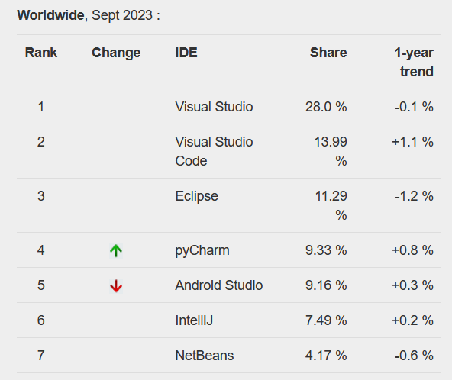

App for iDOO
List students:

Add Student:
Photo, Name, nick name, English name, date of birth, male female, left/right hand, School join date, height, weight, Food allergy, Medical history, home address.

Student daily record: Parents can see.
Photo, work time, child work (choose from category – Practice life, Sensory, Match, Language), Text. Different ways of writing report???

School Notice:

Parents app.
Add child:
Invitation code, relationship.

Growth - See the report.
Gneral - Request holiday, medical details, Student food eating pattern, student sleep pattern, toilet pattern.
Parents education related – iDoo.
Share to friends

Development without coding
Zapier for connecting other apps https://zapier.com/
Connect with other apps https://www.integromat.com/en/integrations
Firebase for database. https://firebase.google.com/

List of all the brands: https://www.nocodejournal.com/state-of-nocode

Develop app using web based drag and drop tool.  Can’t build native app. Can’t host outside of bubble. Can’t export the code/app outside of bubble.  When subscription stop, the app stop working  No | https://bubble.io | Hobby free.  Personal US$25 per month.
Build app from google sheet excel file.  It has template for school | https://www.glideapps.com | Personal free, but 10% transaction fee.  Personal US$12 per month
Microsoft Power app – need to check  No | https://powerapps.microsoft.com/en-us/build-powerapps/ | Looks like only business can use, personal email address not accepted.
Has several inbuilt tempates/API.  Can help to publish on apple store and google play.  When subscription stop, the app stop working  No | https://www.appypie.com | US$60 per month per app for both android and apple
Looks suitable for simple website. Doesn’t have lot of feature for business logic.  Can build and distribute as stand alone native app. | https://www.appgyver.com/ | Free for personal and small company
Buildfire takes care of the submission process to both Google as well as Apple.  Need their subscription to have the app work on google play and apple store  No | https://buildfire.com/ | US$160 per month
Can push app to Google play and app store  Need their subscription to have the app work on google play and apple store  No | www.adalo.com | Free, US$50 per month.
Audio related apps | Voice flow
Only computer browser application.  No | https://webflow.com
One page website.  No | https://carrd.co/
Push to google play and apple store. Free iphone app review.  Several templates available  Need their subscription to have the app work on google play and apple store  No | www.goodbarber.com | US$1400 per year
 | https://shoutem.com | US$80 per month for both android and ios
Android and ios native. Try this | https://www.biznessapps.com | US$99 per month
Focused on enterprise clients. No | https://www.bettyblocks.com | Very expensive
Meant for process automation and for enterprise. No | www.appian.com | Very expensive
Deploy through their app. Users receive email for the app link. Has lot or ready made features.  No | https://www.zoho.com/creator | US$20 per month per user.  Looks expensive to run.
 | https://www.convertigo.com/

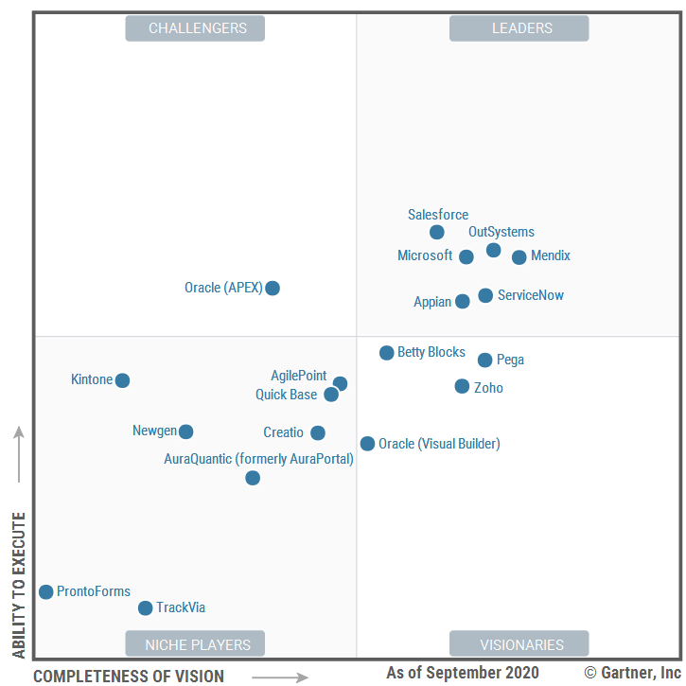
Cross platform app development:
https://www.goodfirms.co/blog/best-free-and-open-source-app-development-software-solutions

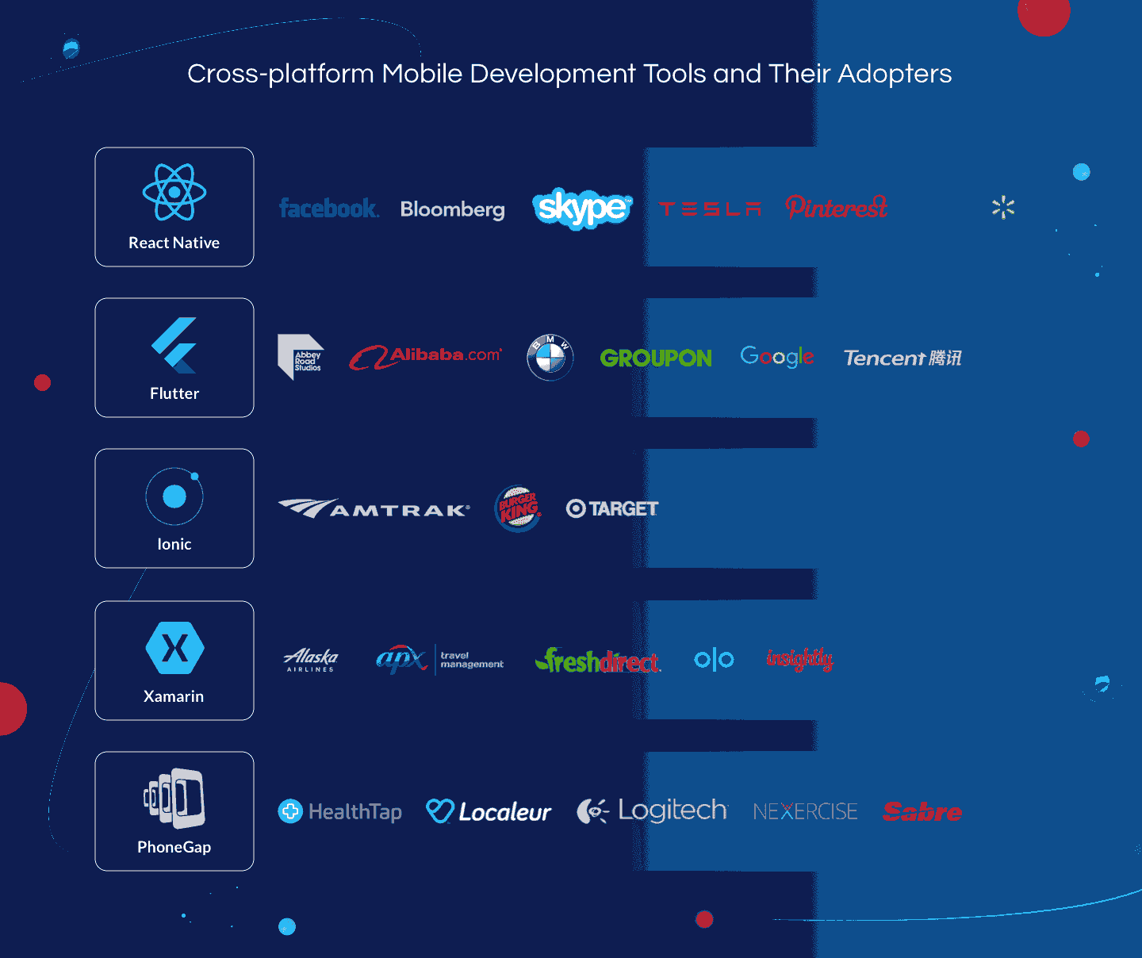
https://litslink.com/blog/best-cross-platform-mobile-development-tools-in-2020
Flutter is open source.
1. Xamarin. Looks like a better tool. However, require Mac to test iPhone apps. https://www.codemag.com/article/1401051/Developing-Cross-Platform-Mobile-Apps-using-Xamarin
Its from Microsoft: https://dotnet.microsoft.com/apps/xamarin

2. RhoMobile
3. NativeScript
4. Kony Mobile Platform
5. Monocross
6. Sencha Touch
7. Appcelerator
8. PhoneGap
9. Codename One

IDEs:
IntelliJ
· Visual Studio
· Cocos2D
· Qt
· MobinCube
· AppsMoment
· RubyMotion
· Ionic
· Dropsource
· Yapp
· Corona

Mobile app hosting
Firebase, https://firebase.google.com/ is a google company to host mobile app. Free for initial use, then Google rate.
Flutter and Firebase work hand-in-hand to help you build mobile apps in record time. Flutter is Google's SDK for building mobile apps for iOS and Android. Firebase gives you access to backend services for mobile applications—including authentication, storage, database, and hosting—without maintaining your own servers. https://codelabs.developers.google.com/codelabs/flutter-firebase#0

Back4App – open source. https://www.back4app.com There is a free service

Backendless –. https://backendless.com, can integrate with Flutter, appgyver
Similar to Backendless is www.kumulos.com

Django:
Django is better than Node JS based web application. Use Django for the AI application.

FastAPI is a new alternative for Django. It can run on Unicorn, which open source. FastAPI is better for microservice based architecture for AI.

PIP is a Django package installation command.
pip --version
pip install <package name>
pip uninstall <package name>
pip list = to list all packages listed on the system.

- Admin login: https://managedsecurityservices.org:2083/
- Django can be installed on GoDaddy hosting through cPanel. See the you tube video.
- Django can’t be integrated with Wordpress, wordpress is based on php. To design Django website, take HTML website and put on Django.
- https://www.templatemonster.com/website-templates/newsz-newspaper-blog-journal-and-magazine-html-website-template-326213.html
- https://demo.templatemonster.com/demo/268737.html?_gl=1*1a6a568*_ga*ODc5MzgzNDAyLjE3MTgxMDY5NDY.*_ga_FTPYEGT5LY*MTcxODEwNjk0NS4xLjEuMTcxODEwNzE1Mi41My4wLjA.

11 Jan 2026:
https://www.djangoproject.com/ - tutorial

WordPress, Website:

VW Themes: License Key: UU4E-PCO4-XTFI-44R5
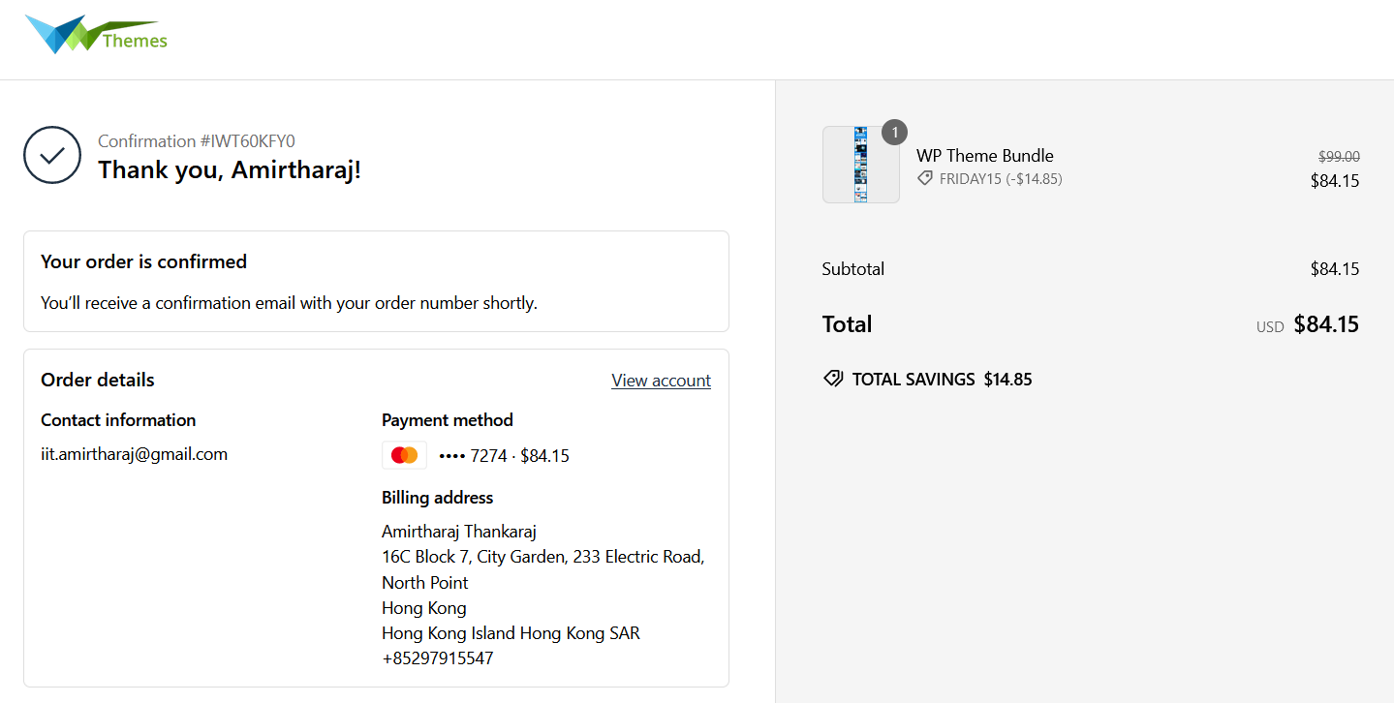
Instruction for how to configure Premium Theme: https://preview.vwthemesdemo.com/docs/vw-eco-nature-pro/

GoDaddy Hosting related information:
The host name: wcoy7lubo3du
Domain mapping for idoomontessori: /home/wcoy7lubo3du/public_html/idoomontessori.com/

General Hosting Information
25 Jan 2026:
Migrating from GoDaddy to other related information:
- IONOS is expensive – no
- Bluehost, Hostgator, Hostinger – does not support python/Django
- Namecheap – Supports Python/Django, however, does not provide SSL after 1 year. Rs1010 per year for SSL certificate. Checking on 15th Apr shows that SSL is free for 50 sites. Two years US$131 = Rs12, 240 for 2 years. Data center available in Singapore.
- https://comodosslstore.com/ - Rs730 per year for SSL.
- Cloudflare is providing free SSL certificate.
- Hosting.com – expensive
- Ovhcloud.com – looks cheaper. It is not clear Django is supported or not. Need to check. Data center in Canada. Personal hosting US$ 4.39 per month = Rs 14,760 for 3 years.

- Solution looks like: Namecheap along with cloudflare free SSL.

WordPress is a webserver software written in PHP, which can run on Apache with MySQL as database. It can be used directly at any host service provider eg: DreamHost, or install offline at local computer.
Offline local WordPress can be updated/sync to the hosting server using Filezilla. FileZilla is from Mozila. Hosing provider must provide the SFTP feature with login & password to connect.

WordPress require Apache HTTP server, PHP, MySqul (MariaDB). Apache HTTP server is not released by apache, it only provides source code. So, needs to use another tool provider. There are many: https://wordpress.org/support/article/installing-wordpress-on-your-own-computer/

One of the good one is: Bitnami.
Install multisite Wordpress on desktop or cloud using Bitnami: https://bitnami.com/stack/wordpress-multisite
WAMP: https://bitnami.com/stack/wamp/installer

Free SVG files: https://openclipart.org/
Content feed: https://www.pipes.digital/
https://beebom.com/yahoo-pipes-alternatives/
https://ifttt.com/
https://wordpress.org/plugins/feedwordpress/
https://www.cminds.com/top-rss-aggregator-wordpress-plugins

IIT Amirtharaj IIT amirtharaj

09 Oct 2021 – discussion with Ravi
Google adsense. Google analytics. G Site Kit
rshankar.com
Genesis themes, google search conscole.
Sitemap plugin to install.

Can develop directly at the hosting server eg: DreamHost, using their tool.
Or have local host at locally and then deploy. To have it on local computer, first need to install local host. There are several software free and paid available. https://wordpress.org/support/article/installing-wordpress-on-your-own-computer/

Alibaba cloud hosing 1 website US$5.9/month https://www.alibabacloud.com/product/hosting?spm=a3c0i.7938564.8215766810.2.4d7a441exK5tvF
Ali cloud has word press plugin.
Dream hosting is not accessible in China.

Dream hosting and blue hosting are similar. Dream Hosting has daily free backup, its cheaper than blue hosting. Dream hosting looks better for me.

Ravi Shanker hosting his website in dream host and domain in godaady.
https://www.dreamhost.com/
CloudServiceManagement.org, CloudSecurityManagement.org, Karungal.org.
iitAmirtharaj, IITamirtharaj
Karungalamirtharaj
tamila.io
Tamilan.io
tamilaa.org
gotamila.org
gotamila.in
asktamila.in
asktamila.com
asktamila.org
tamilatamila.co
tamilatamila.in
tamilulagam.org
valkai.org
valkai.in
tamillife.org
tamillife.in

Eetu churaikai karikku udavadu.

Domains available:
anglingamirtharaj.com
Ailingthankaraj.com
Ailingonline.com

WordPress Social media (Facebook, google etc) integration:
https://www.elegantthemes.com/blog/wordpress/facebook-login-wordpress
Nextend plugin: https://nextendweb.com/social-login/ - facebook, google, twitter login are free, for others need to buy
Ultimate member plugin: https://ultimatemember.com/extensions/social-login/
Paid service, stream Facebook, Youtube etc into your website. https://smashballoon.com// Free version allows to display only text and links.
Embed text, video, post etc into website is freely available from Facebook: https://developers.facebook.com/docs/plugins

Website design templates:
https://themes.getbootstrap.com/
https://themes.getbootstrap.com/product/blogzine-blog-and-magazine-bootstrap-5-theme/
https://themeforest.net/category/all

Video/News blog:
https://themearile.com/themes/
https://wordpress.org/themes/centralnews/

Video blog theme: https://themezhut.com/themes/hitmag/
https://wordpress.com/theme/canard?tab_filter=magazine&tier_filter=free
https://wordpress.com/theme/gazette?tab_filter=magazine&tier_filter=free

https://themeforest.net/item/suround-vlog-blog-html-template/22562864
https://themeforest.net/item/vividly-video-blog-html-template/28655973
https://themezhut.com/themes/hitmag/

https://themeforest.net/item/vlog-video-blog-magazine-wordpress-theme/15968884
https://wordpress.org/themes/vlogger-video-blog/

https://www.vwthemes.com/themes/newspaper-wordpress-theme/ - Chat with them. All can be bought for $99. India based company.
https://www.vwthemes.net/vw-video-vlog-pro/
https://www.vwthemes.com/products/premium-magazine-wordpress-theme
https://www.vwthemes.com/collections/blog

https://colorlib.com/wp/news-website-templates/
https://www.bootstrapdash.com/bootstrap-news-website-templates/
https://themeforest.net/item/24h-news-broadcast-news-tv-channel-news-magazine-template/18614179?ref=web14&__cf_chl_captcha_tk__=pmd_q7OKUQWCkUZRrs88HaIJMUQ0AcwQjoNRkdVK1JGc5ps-1631618846-0-gqNtZGzNA1CjcnBszQeR

https://wphoot.com/
https://wpenjoy.com/themes/
https://newsup.themeansar.com/newslive/

Woo Commerce: https://woocommerce.com/

Online chatbot: https://www.tawk.to
Free photos and videos: https://pixabay.com/

-------------------------------------------------

Android

Developer.android.com/design, Material.io – for design examples
https://developer.android.com/docs/- for documentation. Locally available at User/Amirtharaj/Library/android/sdk/doc

28 October 2019:
Linux Kernel Android run time (ART) and Libraries (Java, Android, C/C++) Application framework
ART converts byte code into native instructions.
Application Framework contains – Activity Manager, Windows Manager, Package Manager, Content Providers, Telephony Manager, Location Manager, View System, Notification Manager, XMPP Service.
Application components: Activities, Services, Broadcast receivers, Content providers.

AppCompatActivity in MainActivity is the class for backward compatibility.
Need to learn the layout xml.
constraintLayout is the default in SDK.
LinearLayout is better for learning.

AndriodMainfest.xml – file is the starting XML file, it tells the information about the app to build, OS, google play MainActivity under java folder – file has the kotlin code, MainActivity is like the main function for start of a program activity_main.xml file under res/layout folder – file has the XML for screen layout
Gradle Script is used for code build/compilation.
The .iml file is for SDK, has the project patch details.

Views extend View class. TextView, Button, ImageView, CheckBox are types of views.
LinearLayout is a ViewGroup. ViewGroups are containers that holds other views. Layouts are organized in a hierarchy in XML.
Kotlin code in MainActivity is responsible for interactive part of the app. Eg: what happens when click a button.
findViewById(R.id.idname) method to get a reference to the View
An integer constant is created in R class for the @+id.
R is a final class in Kotlin. “final” means the class can’t be extended.

SetOnClickHandler() function is invoked each time the user clicks or taps.
Toast is a message that pops up the screen for a short time.
Toast.makeText() require a context, text and duration. Context object allows Toast to communicate with OS to display the text. AppCompactActivity is a subclass of Context. So this can be used as context. show() method displays the message.

Image resources to be kept at drawable folder under res folder.
ImageView class is to display image. Bitmap to display PNG, JPG, GIF, WebP files; Drawable to display vector drawing.

Every time findImageByID() is called, it takes system resource. The better way is to get it first, keep it in a variable at first time in the onCreate main function (which will call the other function).
In ImageView, anything with tools: name space (instead of android:) is displayed only in SDK, not in actual application. Its removed during compilation
Sync with Gradle files – do every time the gradle file is modified
app: name space is for attributes come from your custom code or from libraries, not from core android framework.
App:srcCompact uses Android X library to support older version vector drawables.

To make the top status bar in application:
window.decorView.systemUiVisibility = View.SYSTEM_UI_FLAG_VISIBLE
actionBar?.show()
To disable, change this code.
Toolbar to manage the top application bar. (Better don’t use ActionBar)

Below is the hierarchy menu is aligned in menu_main.xml file
<menu>
<group>
<item>
</item>
</group>
</menu

onCreateOptionsMeu(menu) function add items into the menu.
onOptionsItemSelected() function add items into the options menu overflow inside the menu.
Floating Action Button is button on top of the page.
Snacbar is the area to display message at the bottom and it fads away.

To change the application icon image – on “res” right client, create new image (or victor), then use the pop up window. (take image from folder or use the existing clip art)

Visit these liks for sample code:
https://github.com/googlesamples
https://github.com/android

Glide is a 3rd party image loading API for android.
The LinearLayout has the required attributes layout_height, layout_width, and orientation, which is vertical by default.
It has left, right, top, bottom. android:xxx.
For Android 4.2 and above use start and end, instead of top and bottom.

ScrollView to make scroll view.
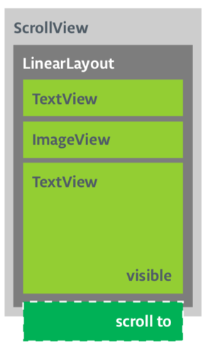
LineSpacingMultiplier – add space in the text. It should be dp or sp, not absolute number.

14Nov 2019:
When I add image view to the ScrollView, the application didn’t load. Also, when I put ScrollView at another place, same error. Unfortunately app stopped error.
Instead of ScrollView, use NestedScrollView. (See Scrool view template example)

On the Design view for activity_main.xml, under Text underlined items means editable, non underlined means display (non editable)
Style attribute is used to change the button colour.
Drawable attribute is used to add image on the button.
fontFamily attribute is used set the font type.
Visibility attribute – gone, is not visible also does not take space in the view. Invisible is not visible but takes space, visible is displayed and takes space.

19 Nov 2019:
private fun clickHandlerFunction(viewThatIsClicked: View) {
// Add code to perform the button click event
}
Click listener can be done two ways: use android:onClick on the xml or create setOnClickListener function within onCreate.
android:onClick="clickHandlerFunction"/>. Then the function has to be Public and return Void.

myButton.setOnClickListener {
clickHanderFunction(it)
}

import.android.view.* - it imports all package inside view.
import.android.view.View = package required to set visibility.
findViewById – can be used in two ways. First declare the type (text or button etc) and thenget it; or do it directly by putting the type inside <> - findViewById<Button>(R.id.xxx).setOnClick….
“it” refers to the current view.
https://developer.android.com/guide/topics/text/autofill-optimize - learn about autofill
hideSoftInputFromWindow – to hide the soft keyboard from display. Need to import Context package.

// Hide the keyboard.
val inputMethodManager = getSystemService(Context.INPUT_METHOD_SERVICE) as InputMethodManager
inputMethodManager.hideSoftInputFromWindow(enteredText.windowToken, 0)
Here, enteredText is the name of the filed where key board is used.

// Set the focus to the edit text.
editText.requestFocus()

// Show the keyboard.
val imm = getSystemService(Context.INPUT_METHOD_SERVICE) as InputMethodManager
imm.showSoftInput(editText, 0)

Constraints layout sets each other entities in relations to others. All needs to be defined.
A chain is a group of views that are linked to each other with bidirectional constraints.

Alternatively, you can add chain styles in the XML code. For example:
// Horizontal spread chain
app:layout_constraintHorizontal_chainStyle="spread"
// Vertical spread inside chain
app:layout_constraintVertical_chainStyle="spread_inside"
// Horizontal packed chain
app:layout_constraintHorizontal_chainStyle="packed"

Styles are defined in values/styles.xml file. The color and other names in that file is defined in res/values/colors.xml file. Referred as >@color.
<item name="colorAccent">@color/colorAccent</item>
They style can also use color from android like below:
<item name="android:background">@android:color/white</item>

colorAccent is the color of image background.
HTML coor code: #Red Green Blue, 00 00 00 is black, FF FF FF is white.

21 Nov 2019:
Using findViewById() every time takes resources and make the app slow. The better way is to create an object that contains a reference to each view, called Binding object. Binding object can be used by your whole app. Once the binding object is created for the app, view and other data can be accessed through binding object. It helps data & views separated.

Data binding to be manually enabled in Grade file. build.gradle (Module: app) under android.
dataBinding {
enabled = true
}
Needs to add <layout></layout> tag into the xml file. So that binding object can know the views inside the layout. <layout> should be the outermost tag, xmlns should be included into it.
Needs to do binding declaration and assignment in kotlin file, replace the setContentView method with DataBindingUtil. Needs to import this package. Replace all findViewById function with binding.id name.

Jenkins – LinkedIn Learning
27 Nov 2023:
Commands to install Jenkins on Docker
Jenkins is installed on Docker. Docker installed on Kali linux.
docker --version
docker pull jenkins/jenkins:lts
docker run --detach --publish 8080:8080 --volume jenkins_home:/var/jenkins_home --name jenkins jenkins/jenkins:lts
docker exec jenkins cat /var/jenkins_home/secrets/initialAdminPassword

jenkin login at localhost:8080, jenkins/jenkins.

Apache Maven is a build automation tool used primarily for Java projects.
Apache Ant is to build Java (and c c++) applications.

New Item is to create new project/build.
Build Trigger is the condition to start the job.
The workspace can be cleaned up before building or after the build is completed.
Views – filter to show the jobs, when there are many jobs.
Folders – grouping jobs similar to file folder system. Create Folder same as creating a New Item, choose Folder.

Pipeline as a code. Automate the entire process. Create it same as creating a New Item, choose Pipeline. It is a script file, which runes source repositories and branches without manual creation of jobs. File named “Jenkinsfile” must be in the repository root, which contains pipeline script.
Pipeline contains Stages.

When I installed OWASP ZAP into Jenkins, it didn’t start. I stop and started from docker cli, and then it worked.
sudo docker stop jenkins
sudo docker start jenkins

Video Making:

17 May 2025:
OBS studio is a good open source free video screen recording and editing software.
Conva can be used to create animation videos.

Useful tools to create training videos: https://community.udemy.com/en/kb/articles/100628

Other video scribing software:
https://app.animaker.com/editproject/4yHjeeSGv5oz4mzv - US$25 per month, no free
https://www.flexclip.com/ - Max 10 min video is free. US$20 per month
https://www.scribely.co/app/ - 3 five minutes video is free. SU$19 per month
https://www.toonly.com/ - No free, US$45 per month
https://www.renderforest.com/ - 3 min video with water mark is free. US$14 per month
Create online course Paid, not free: https://www.voomly.com/ - US$14 per month

Arduino:
For wifi: https://store.arduino.cc/usa/arduino-uno-wifi-rev2
https://store.arduino.cc/usa/mkr-wan-1300
https://store.arduino.cc/usa/nano-33-iot-with-headers
Mobile connectivity: https://store.arduino.cc/usa/mkr-gsm-1400
Sensors: https://store.arduino.cc/usa/gravity-37-pcs-sensor-set-for-arduino
https://www.home-assistant.io/
https://create.arduino.cc/projecthub/jithinsanal1610/home-automation-using-arduino-arduino-diy-project-6c03ba

Hardware design: https://fritzing.org/download/
https://processing.org/
Connect mobile/computer to control hardware
https://remotexy.com/
https://blynk.io/pricing

Scratch
Scratch Link – app available for Windows.
Scratch Link is a helper app that lets you connect Scratch to other devices, such as micro:bit and LEGO robotics kits.
https://scratch.mit.edu/microbit
Trello drone can be programmed using Scratch. https://www.ryzerobotics.com/tello

MICRO:BIT
micro:bit (V2) with built-in microphone and speaker
Microbit projects: https://www.seeedstudio.com/blog/2019/12/10/top-25-microbit-projects-for-beginners-2019/

Microsoft makecode https://www.microsoft.com/en-us/makecode
Dash is a moving robot, which can be programmed. https://www.makewonder.com/
Lego education.
Paper circuit https://chibitronics.com/

www.mobizen.com and Airdroid are to remote manage android device.
Microbit projects: https://makecode.microbit.org/projects/banana-keyboard
https://makecode.microbit.org/#

Robot, Raspberry Pi:

China Hangzhou company Unitree making humanoid robots: https://www.unitree.com/
Other few companies in China:
https://en.engineai.com.cn/ - Shenzhen company
https://www.deeprobotics.cn/en
https://www.agibot.com/
Humanoid robots and companies in China: https://www.aparobot.com/countries/china

LiDAR light detection and ranging technology is used as sensor for robots. It function similar to radar however LiDAR uses laser light. It is more accurate that radar.

Lidar and PyLidar are python packages for LiDAR.

27 Dec 2021:
Control Raspberry pi port to control external light through cayenne service. Video: https://www.youtube.com/watch?v=VOxADFHZ75Y
https://developers.mydevices.com/cayenne/features/

HAT – Hardware At Top
Relay for Raspberry pi.

SIM com SIM800L for cell phone connection, GSM module.

Robot:
Raspberry pi robot kits: https://raspberrytips.com/best-raspberry-pi-robots-kits/
How to build robot: https://projects.raspberrypi.org/en/pathways/build-a-robot
Personal assistant robots: https://www.spykeeworld.com/best-personal-assistant-robot/
Robot operating system ROS: https://www.ros.org/integration/
Robot base: http://www.slamtec.com/en/Apollo
机器人底盘
树莓派散热片
ros机器人
Simultaneous Localization and Mapping (SLAM)
Single Board Computers
开发板
人形机器人

Windows IOT:
Dragon board: https://developer.qualcomm.com/hardware/dragonboard-410c
NXP: https://www.nxp.com/products/processors-and-microcontrollers/arm-processors/i-mx-applications-processors/i-mx-8-processors:IMX8-SERIES

Toy brick: http://t.rock-chips.com/en/portal.php?mod=list&catid=1
Rock Pi: https://www.allnetchina.cn/rockpi

Turtlebot: https://www.turtlebot.com/

Robot company in Beijing: http://www.jingtianrobots.com/en/

Mozilla WebThings – control home IOT using Raspberry pi: https://iot.mozilla.org/docs/gateway-user-guide.html

Particle is an open source popular iOT platform: https://www.particle.io/

OS for Raspberry Pi
https://www.fossmint.com/operating-systems-for-raspberry-pi/
Windows IOT won’t run wondows applications.
Ubuntu Desktop can run on Respberry PI 4, but need 4 o 8 GB RAM

Real time computer vision software library. Real time image processing. https://opencv.org/
Openb source interactive computing. https://jupyter.org/

Jetson Nano is a small powerful hardware from NVIDIA for edge computing – robotics, AI. https://www.nvidia.com/en-us/autonomous-machines/embedded-systems/jetson-nano/product-development/
Coral Dev Board is similar to Jetson using Google’s Edge TPU.
Rock Pi looks similar to Raspberry Pi https://rockpi.org/

Python is used in AI. Fortran and C++ are used in HPC.
Django is a web framework for python web development. https://www.djangoproject.com/

Raspberry Pi projects: https://www.seeedstudio.com/blog/2019/09/29/top-20-best-raspberry-pi-4-projects-that-you-must-try-now/

Kodi is a open source media streaming software using existing videos. https://www.pcmag.com/news/what-is-kodi

Raspberry Pi projects:
https://www.seeedstudio.com/blog/2020/01/14/how-to-create-and-run-a-raspberry-pi-python-program-beginners-tutorial/
linux applications list: https://www.fossmint.com/most-used-linux-applications/
Remove connect Ubundu from Windows:
All these didn’t work : https://github.com/neutrinolabs/xrdp
https://websiteforstudents.com/connect-from-windows-10-to-ubuntu-18-10-18-04-16-04-with-xrdp-rremote-desktop-protocol-rdp/
https://www.makeuseof.com/tag/how-to-establish-simple-remote-desktop-access-between-ubuntu-and-windows/
All the remote connection software available are only from Linux/Ubuntu to other Linux or Windows. None from Window to view Ubuntu.
RealVNC Free is home use version. It require registration. – RealVNC didn’t install on Ubuntu

WeChat Related:

07 Jan 2020:
WXML – WeiXin Markup Language.

Index.wxml is the first file to display.
Class listed in index.wxml are CSS definitions defined in *.wxss files.
<view class=”the class name”> </view>

WXSS is for style. rpx (responsive pixel): Adaptable to the screen width.
Use @import “name.xcss”; to import style sheet.
Global style is defined in app.wxss and it applies to all pages. Local style is defined in other wxss file specific to the local file.

wxs - WeiXin Script is similar to Java Script for mini program scripting. It doesn’t depends on the run time. Its faster in iOS than JavaScript and similar fast in Android.

25 Jan 2020:
Line-height should be 1.4 times the font size.
Opacity – transparency of the text, 0 is fully transparent 1 is non-transparent.
Padding-top – to allow the space above.
Padding-bottom – to allow space below.
To add background image,
<cover-image class="weatherImage" src="/images/sunny-bg.png"></cover-image>

07 Dec 2019:
Wechat tools: https://chinachannel.co/wechat-tools-platforms/
Wechat open platform: https://open.weixin.qq.com/cgi-bin/index?t=home/index&lang=en_US
Mobile app development: https://open.weixin.qq.com/cgi-bin/frame?t=home/app_tmpl&lang=en_US

Montessori Related:
MRX: https://www.montessorirecordsxpress.com/?home.html
http://www.appchina.com/app/com.montessori.msnotes
US standard: http://www.corestandards.org/

India Chennai has 1 month foundation course in August 2020, application deadline is June. http://www.navadisha.org/Index.php/courses
Similar program in USA.
60 hour support program: https://montessoricentermn.org/montessori-training-programs/assistants-training/
https://www.trilliummontessori.org/
https://www.mariamontessori.org/training/what-we-offer/ami-assistants-courses/ami-assistants-certificate/
https://montessori-nw.org/teacher-preparation

https://www.mariamontessori.org/training/training-fees/
http://www.montessoribangalore.org/courses/show/20

19 Nov 2019:
Alex from Le Wagon. Jake from Le Wagon.

WXML, WXSS, JS.

Wechat mini program is used for user to quickly complete the work. However, the general app is to keep user on the app for long time.
Tencent doesn’ thave a location to find mini program. There is one place to find is: https://minapp.com/miniapp/
Need to register for wechat official account: https://mp.weixin.qq.com/cgi-bin/loginpage?t=wxm2-login&lang=en_US&token=

API server/backend to be managed by ourself.
WXML for content and structure, WXSS for style, JS for dynamism + usability.
Use id to identify the elements in the wxml.
Use class to have several items as group.
https://workshop.wechatdevelopers.com/ - the sample code from the class.
----------------------------------------------

General Note:

For freelancer: Fiverr, Upwork,

Office 365 can be installed on Ubuntu: https://www.how2shout.com/linux/install-micrtosoft-office-365-on-ubuntu-20-04-linux-without-wine/#:~:text=Install%20Office%20365%20Web%20app%20Wrapper%20on%20Ubuntu,and%20login%20with%20a%20Microsoft%20account.%20%20

Hong Kong government data API details to use in APP: https://data.gov.hk/en/

Open source FTP client: https://filezilla-project.org/

Products specific to schools, college, hobby related projects;
https://www.instructables.com/circuits/
https://rarecomponents.com
Chat https://www.tawk.to/

Fedora is a unix based fee OS for desktop. It is open source supported by RedHat.
Golang is used in Hyperledger fabric. R3 Corda uses Kotlin
???webtalk

Raspberry Pi 3 is compatible with Android Things.
Intel Edison
NXP i.MX7D

Microsoft has similar IOT, Azure Sphere is the OS and several hardware from: Avent, Seeed, AI-Link, USI

Chainlink is a company which connects blockchain with any other real world payment.

Hashgraph is a distributed ledger technology from Hedera. IBM is in the governing council.
https://www.makerbay.org – workshop rental space to develop things.

Think of developing something on Wechat and Whatsapp.

